**DEVELOPMENT OF AN ONLINE RECORDS MANAGEMENT SYSTEM FOR INTEGRATION**

A Capstone Project Proposal Presented to the

Faculty of College of Computer Studies

**BENEDICTO COLLEGE – MANDAUE CAMPUS**

A.S. Fortuna St., Mandaue City, Cebu

In Partial Fulfillment of the Requirement for the

**Bachelor of Science in Information Technology**

LOURD ANGELO D. BUFETE

LY ANN KATE A. CANDIDO

ROY P. ESTORCO

ROMY A. FORMENTERA JR.

JADE STEVE MOLEJON

RAQUEL PACURE

May 2025

**APPROVAL SHEET**

The Capstone Project Proposal entitled “**AUTOMATED REGISTRAR’S SYSTEM: ENHANCING RECORDS MANAGEMENT AND ACADEMIC SERVICES AT BENEDICTO COLLEGE**” prepared and presented by Lourd Angelo D. Bufete, Ly Ann Kate A. Candido, Roy P. Estorco, Romy A. Formentera Jr., Jade Steve Molejon, Raquel Pacure in partial fulfillment of the requirements for subject Capstone 1 will be examined and presented for acceptance and approval for **Oral Examination.**

**ABSTRACT**

|  |  |
| --- | --- |
| TITLE | AUTOMATED THE REGISTRAR’S SYSTEM: ENHANCING RECORDS MANAGEMENT AND ACADEMIC SERVICES |
| BACKEND DATABASE PROGRAMMER  PROJECT MANAGER  BACKEND PROGRAMMER  FRONTEND PROGRAMMER  RESEARCHER  DOCUMETARIAN | LOURD ANGELO D. BUFETE  LY ANN KATE A. CANDIDO  ROY P. ESTORCO  ROMY A. FORMENTERA JR.  JADE STEVE MOLEJON  RAQUEL PACURE |
| DEGREE | BACHELOR OF SCIENCE IN INFORMATION TECHNOLOGY |
| ADVISER | PROF. LENY B. YAMILO |
| INSTITUTION AND ADDRESS  DATE COMPLETED | BENEDICTO COLLEGE, A.S. FORTUNA ST., BAKILID, MANDAUE CITY  MAY 31, 2025 |
| NUMBER OF PAGES | 34 PAGES |

Efficient records management is crucial in today’s academic landscape, yet many institutions like Benedicto College still rely on manual processes that cause errors and delays. This study, “Automated Registrar’s System: Enhancing Records Management and Academic Services,” aims to develop an Automated Registrar Office System to streamline student records and optimize administrative tasks. Designed using HTML, CSS, and JavaScript with MySQL for data storage, the system enhances accuracy, reduces processing time, and improves efficiency. Its implementation is expected to significantly boost transparency, accessibility, and reliability in student records management at the college.

**Keywords:** Automated registrar system, Academic records management, Web-based system, MySQL database, Digital transformation in education, administrative efficiency.

**ACKNOWLEDGEMENT**

We extend our deepest gratitude to everyone who contributed to the completion of this research paper.

First and foremost, we sincerely thank **God** for His countless blessings, guidance, and strength throughout this journey. Without His divine support, this work would not have been possible.

We are profoundly grateful to our **President, Lilian Benedicto-Huan**, for her unwavering leadership and commitment to academic excellence. Her dedication to fostering an environment of learning and innovation has greatly inspired us.

We are profoundly grateful to our **Dean, Prof. Gene Paul R. Cueva**, for his invaluable mentorship, encouragement, and insightful feedback. His expertise and unwavering support have been instrumental in the success of this project. Thank you for believing in us and inspiring us to strive for excellence.

Our heartfelt appreciation goes to our **research adviser, Leny B. Yamilo, DPA(Diss.), LPT**, for her guidance and constructive feedback throughout the research process. Her expertise and encouragement have played a crucial role in shaping this study.

We also extend our gratitude to our **research panelists** for their critiques, suggestions, and mentorship, which have significantly enhanced the quality of our research.

To the participants who generously shared their time and insights, we offer our sincere thanks. Your contributions have been integral to the success of this study.

Lastly, we are deeply thankful to our **families and friends** for their unwavering support, patience, and encouragement. Your belief in us has been a constant source of motivation throughout this academic pursuit.

Above all, we acknowledge **God’s divine guidance and grace**, which have illuminated our path, strengthened us in times of difficulty, and granted us the wisdom to persevere.

- The Researchers

**DEDICATION**

To my parents, whose love and support have guided me, to my adviser for invaluable mentorship, and to my friends and partner for their unwavering encouragement, this work is dedicated to you.

* Lourd Angelo D. Bufete

To those who have influenced my journey, from instructors who sparked my interest to peers who pushed me. This accomplishment reflects our collective growth and commitment to learning.

* Ly Ann Kate A. Candido

To my friends, whose compassion and support have made this journey meaningful. Your encouragement has given me courage and joy. This work honors our shared experiences.

* Roy P. Estorco

To the hours of perseverance, passion, and determination that led to this achievement. May it inspire others to pursue their goals with dedication.

* Romy A. Formentera Jr.

To the opportunities education unlocks and the teachers, mentors, and family whose support has helped me succeed. May this work inspire future endeavors.

* Jade Steve Molejon

To my parents and loved ones, whose sacrifices and faith have driven me, and to my mentors and friends who guided and supported me, this achievement is dedicated to you.

* Raquel Pacure

**TABLE OF CONTENTS**

**TITLE PAGE**

APPROVAL SHEET ii

ABSTRACT iii

ACKNOWLEDGEMENT iv

DEDICATION vi

TABLE OF CONTENTS vii

**Chapter 1 PROBLEMS AND ITS SCOPE**

Rationale 1

Theoretical Background 3

Statement of Problem 7

Scope and Limitation 10

Significance of the Study 11

**Chapter 2 REVIEW OF RELATED LITERATURE AND STUDIES**

Related Literature 14

Related Studies 16

**Chapter 3 TECHNICAL DEVELOPEMENT**

Development Software 19 Reference 25

**Chapter 1**

**THE PROBLEM AND ITS SCOPE**

**Rationale**

In contemporary academic institutions, particularly those experiencing consistent enrollment growth, the integrity, efficiency, and reliability of records management have become fundamental operational concerns. The Registrar’s Office, as the official custodian of student academic records and an administrative arm responsible for the issuance of academic documents and enforcement of institutional policies, plays a pivotal role in the overall academic governance of an institution. Despite the centrality of its function, many registrar offices, especially in developing educational institutions, remain dependent on traditional, paper-based systems that are increasingly untenable in the face of modern administrative demands.

At Benedicto College, the persistent reliance on manual processes has given rise to operational delays, data discrepancies, misfiled or misplaced documents, and limited accessibility to academic records—conditions that adversely affect not only institutional efficiency but also the academic experience of students and the ability of faculty and administrators to make data-informed decisions. As student enrollment continues to increase annually, the limitations of a non-digitized records management system become more pronounced, impeding the Registrar’s Office from fulfilling its mandate in a timely and accurate manner.

The increasing demand for academic services at Benedicto College has placed significant strain on the Registrar’s Office, exacerbating inefficiencies in document processing and records management. The manual system, while historically functional, is no longer sufficient to meet the growing needs of the student body, resulting in delayed services, errors in records, and insufficient access to academic data.

This capstone project proposes the development of an Automated Registrar Office Management System at Benedicto College, which seeks to modernize the institution's core registrar functions by implementing a secure, real-time, and structured digital platform. The system is intended to digitize academic records, automate document processing and requests, and provide regulated access to authorized users, thereby enhancing operational transparency, accuracy, and accountability. The system will cover the core functions of the Registrar’s Office, including the digital management of academic records, the automation of transcript generation, certificate issuance, enrollment verification, and real-time access to academic information for students and faculty. However, the implementation of such a system comes with inherent challenges, such as the need for staff adaptation to new technologies, system integration with existing infrastructure, and the potential for technical disruptions. Additionally, continuous evaluation and adaptation to emerging legal and institutional policies will be required to ensure long-term system efficacy.

The primary goal of this initiative is not merely technological innovation but a necessary reform to address the challenges posed by the outdated, existing system. By automating the operations of the Registrar’s Office, Benedicto College aims to streamline academic services, reduce administrative backlogs, and ensure accurate, real-time access to student records. This modernization effort will promote academic excellence, operational integrity, and improved service delivery, while maintaining compliance with relevant data privacy laws and institutional policies.

**Theoretical Background**

The development of an automated registrar system is grounded in several key theories that provide a framework for understanding change management, data processing, user acceptance, and records management. These theories help ensure that the transition from manual to digital processes is efficient, user-friendly, and sustainable. By applying these theoretical foundations, the project aims to modernize academic records management at Benedicto College, improving accessibility, accuracy, and operational efficiency.

**Kurt Lewin’s Change Model (1947).** Kurt Lewin’s Change Model outlines a three-stage process for managing organizational change: Unfreeze, Change, and Refreeze. This theory explains how organizations and individuals respond to transitions and how resistance to change can be minimized through a structured approach.

In the context of this study, the model serves as a guide for shifting Benedicto College’s registrar office from a manual to an automated system. The Unfreeze stage involves identifying inefficiencies and preparing staff for digital transformation. During the Change stage, the system is implemented, and training is provided to ensure proper adoption. Finally, the Refreeze stage ensures that the system becomes a permanent and efficient part of the institution's operations. This theory is essential in planning and managing the transition to ensure successful system integration.

**George A. Miller’s Information Processing Theory (1956).** This theory compares human cognition to the functions of a computer, focusing on how information is encoded, stored, and retrieved. Miller’s concept of “chunking” suggests that users comprehend and retain information better when it is organized into meaningful segments.

This theory applies directly to the design of the automated registrar system’s user interface. Organizing student data into structured, easy-to-navigate sections allows both staff and students to interact with the system more efficiently. Minimizing cognitive overload improves usability, making it easier to locate and process academic records. Thus, the theory supports the system’s goal of creating an intuitive and user-centered interface.

**Stephen J. Andriole’s Information Systems Theory (1986).** Andriole’s theory focuses on how technology can be used to collect, process, and transform raw data into useful information. It emphasizes the integration of software, hardware, and human resources to manage large volumes of data efficiently.

For this study, the theory validates the automation of student recordkeeping. By using a centralized database and automated processes, the registrar system can minimize human error, ensure real-time updates, and provide accurate academic services. The theory reinforces the need for a reliable digital infrastructure to support the growing demands of academic records management.

**Fred Davis’s Technology Acceptance Model (TAM) (1989).** TAM explores the factors that influence whether users accept and use new technology, focusing on two key components: **Perceived Usefulness** and **Perceived Ease of Use**. A system is more likely to be adopted when users believe it will improve their productivity and is easy to navigate.

This model is essential in designing and promoting the automated registrar system. For successful implementation at Benedicto College, the system must be viewed by students and staff as helpful in streamlining services and simple to operate. The model informs the study’s focus on user-friendly design, responsive features, and training efforts to encourage widespread adoption and satisfaction.

**Michael Buckland’s Records Management Theory (2022).** Buckland’s theory views records management as a dynamic and evolving discipline, closely linked to technological advancements. It stresses the importance of digital storage, data accessibility, and systematic retrieval.

This theory is closely tied to the core objective of this project: to modernize how Benedicto College manages academic records. Through the implementation of a digital system, student data can be stored securely, updated in real time, and retrieved efficiently. Buckland’s theory supports the study’s emphasis on security, accuracy, and long-term data integrity.

**AUTOMATED REGISTRAR’S OFFICE SYSTEM**

**Kurt Lewin’s Change Model (1947)**

**George A. Miller’s Information Processing Theory (1956)**

**Stephen J. Andriole’s Information Systems Theory (1986)**

**Fred Davis’s Technology Acceptance Model (TAM) (1989)**

**Michael Buckland’s Records Management Theory (2022)**

**AUTOMATED REGISTRAR’S SYSTEM: ENHANCING RECORDS MANAGEMENT AND ACADEMIC SERVICES**

**Figure 1**

**Theoretical Framework**

**Statement of the Problem**

Educational institutions continue to expand and integrate digital advancements, yet manual processes in registrar offices remain inefficient and outdated. At Benedicto College, managing student records and academic services relies heavily on paper-based documentation and manual data entry, leading to inefficiencies, delays, and errors in record-keeping. The prolonged process of requesting and obtaining academic documents, such as transcripts and certifications, leads to student dissatisfaction and may hinder academic progression.

The registrar’s office experiences excessive workload due to repetitive manual processes, increasing the likelihood of human errors such as data entry mistakes, misplaced records, and inconsistencies in academic records. These inefficiencies hinder operations, slowing down student enrollment verification, document issuance, and record updating.

A lack of a centralized system makes tracking and verifying student records difficult. Without real time access to updated academic information, staff members spend significant time manually cross-checking records, further delaying responses to student and faculty requests. This decentralized approach increases the risk of discrepancies in student data and affects compliance with institutional and regulatory requirements.

Although there is a growing demand for efficiency, transitioning from manual to digital processes presents challenges. Staff adaptation, potential technical difficulties, and the absence of a structured framework continue to hinder the efficiency of registrar operations. These challenges result in administrative inefficiencies, delays in student services, and difficulties in maintaining accurate and reliable academic records.

**General Problem of the Study**

Managing student records and academic services at Benedicto College remains slow, prone to errors, and inefficient due to the reliance on manual processes. The process of handling document requests, issuing transcripts, and updating student records lacks a centralized data management approach, leading to delays and administrative bottlenecks.

Requesting academic documents requires multiple steps, including paperwork, manual verification, and long waiting times before students receive their documents. This inefficient workflow results in data inconsistencies, delays in processing requests, and difficulties in maintaining accurate academic records. The manual system increases administrative workload and contributes to student dissatisfaction.

Data entry errors further complicate academic record management, leading to discrepancies that delay decision-making. Without an automated system, tracking student information, updating records, and ensuring compliance with institutional policies remain significant challenges.

**Specific Problem of the Study**

The current manual processes used by the registrar’s office at Benedicto College in managing student records and academic services result in significant inefficiencies, delays, and errors. One of the primary challenges is the manual method of searching for student records, which involves copying and reviewing names individually. This outdated approach not only slows down transactions but also makes it difficult to retrieve and process student information promptly.

The study aims to address the following specific problems:

1. **Data Retrieval** – The manual system hinders fast and accurate retrieval of student records, leading to time-consuming operations and potential errors.
2. **Report Generation** – Creating academic and administrative reports manually is inefficient and prone to inconsistencies, affecting decision-making and service delivery.
3. **Processing** – Overall processing of student requests and documentation is delayed due to the lack of an automated system, increasing the workload of the registrar staff and reducing productivity.

**General Objective of the Study**

This study aims to address the inefficiencies of the manual registrar system at Benedicto College by developing and implementing an Automated Registrar Office System. The goal is to enhance records management and academic services by streamlining administrative processes, reducing human errors, and improving efficiency in handling student records and document requests. Automating key functions will ensure real-time data updates, secure record-keeping, and a more seamless experience for students and registrar staff.

Additionally, this study seeks to evaluate and analyze the current records management and academic service processes, providing an optimized solution that improves efficiency, accuracy, and user satisfaction. By implementing an automated system, document processing, student record management, and administrative tasks will become more efficient, minimizing errors and enhancing overall service delivery.

**Specific Objectives of the Study**

To address the issues identified in the specific problem such as manual searching of records, difficulty in retrieving information, delayed document processing, and heavy staff workload, this study aims to develop and implement a digital solution that will improve the efficiency and reliability of registrar operations at Benedicto College.

The specific objectives are as follows:

1. To develop a digital student record management system that allows fast and accurate search functionality by student ID or name to minimize transaction time.
2. To implement a centralized and searchable digital database that enables quick (faster) retrieval of student records using various filters.
3. To reduce manual workload by digitizing routine registrar tasks such as record updates, document requests, and verifications through an integrated platform.

To address the issues identified in the specific problems—such as manual searching of records, difficulty in retrieving information, delayed document processing, and increased staff workload—this study aims to design and implement a digital solution to enhance the efficiency and reliability of registrar operations at Benedicto College.

The specific objectives of the study are:

1. To develop a digital student record management system with fast and accurate search functionality using student ID or name, aimed at minimizing transaction time.
2. To implement a centralized and searchable digital database that enables quicker retrieval of student records through various filtering options.
3. To reduce the manual workload of registrar staff by digitizing routine tasks such as record updates, document requests, and verifications through an integrated platform.

**Scope and Limitations**

**Scope of the Study**

The study will focus on the implementation and outcomes of the Development of an Online Records Management System for Integrationat Benedicto College Main Campus. It will explore the following aspects:

* Handles tertiary-level student records and admin tasks.
* Connects with current enrollment, grading, and MIS systems.
* Manages academic records, transcripts, and certifications.
* Automates graduation checks and academic standing.
* The system will enhance efficiency in document processing, reducing manual work for the registrar’s office.

**Limitations of the Study**

While the study aims to provide a comprehensive analysis of the Automated Registration System, several limitations must be acknowledged:

* Tertiary education only (no primary/secondary/vocational).
* Read-only access to existing databases.
* No financial processing capabilities.
* Basic notifications only (no chat/email features). Recommendation: Request Online

**Significance of the Study**

The significance of studying the Automated Registrar Office System at Benedicto College, particularly at the tertiary level, is substantial for various stakeholders within the institution. This study has the potential to benefit the following groups:

**Registrar’s Office.** The Automated Registrar Office System will significantly enhance the efficiency and accuracy of records management within the registrar’s office. By automating manual processes, it will reduce errors, streamline academic record-keeping, and improve response times for student requests. This system will ensure better organization and accessibility of student records, ultimately leading to improved service delivery.

**Registrar Office Staff.** Faculty and staff will benefit from quick and easy access to essential student information, reducing their administrative workload and allowing them to focus more on academic and student support services. The system will also improve coordination between departments when handling student records.

**Students.** The system will offer students faster, more efficient access to their academic records, such as transcripts, certifications, and other essential documents. It will reduce waiting times, improve transparency, and contribute to a more seamless academic experience.

**Parents and Guardian.** An automated registrar system provides parents and guardians with increased transparency and convenience in managing their child's academic records. It allows monitoring progress, tracking grades, and requesting essential documents, reducing paperwork and administrative delays.

**Faculty and Academic Advisers.** Faculty and academic advisors with immediate access to student records, enabling efficient review and guidance. This streamlines processes, enhances academic planning, ensures accurate record keeping, and supports timely decisions.

**School Administration** The administration will gain access to real-time and accurate data on student records, enabling them to make informed decisions regarding academic policies, institutional planning, and operational improvements. Enhanced data management will contribute to the overall efficiency and credibility of Benedicto College.

**Alumni.** An automated registrar system enhances efficiency for alumni by providing quick and secure access to their academic records. This system simplifies requests for transcripts, certificates, and other essential documents, ensuring timely processing and reducing administrative delays. By improving record accessibility and accuracy, the system supports alumni in further education, career advancement, and credential verification.

**School.** The implementation of this system will benefit the school as a whole by improving the efficiency of academic records management. With better data organization and accessibility, the school can enhance its overall academic services, leading to a more effective learning environment.

**Future Researchers.** The findings of this study will serve as a reference for future researchers looking to develop or improve registrar office systems in educational institutions. It will provide insights into system design, implementation challenges, and best practices for enhancing academic records management.

**Chapter 2**

**REVIEW OF RELATED LITERATURE AND RELATED STUDIES**

**Related Literature**

**According to Las Johansen B. Caluza (2017) Development of Electronic Document Archive Management System (EDAMS): A Case Study of a University Registrar in the Philippines.** This study focuses on the creation of an Electronic Document Archive Management System (EDAMS) for the Leyte Normal University. The research addresses challenges in handling approximately 300 daily document requests, highlighting the inefficiencies of manual processes. By implementing EDAMS, the university aimed to streamline document retrieval, reduce processing time, and enhance overall service quality in the registrar's office. This case underscores the potential benefits of automating registrar functions, offering a practical reference for similar initiatives at Benedicto College.

**According to Ojambo Albert (2021) Design and Implementation of an Automated Registration Management System: A Case Study of Our Lady Seat of Wisdom Secondary School.** This thesis explores the design and implementation of an Automated Registration Management System at Our Lady Seat of Wisdom Secondary School. The system addresses challenges associated with manual data storage, aiming to improve data accessibility, integrity, and security. By automating registration processes, the school enhanced the efficiency of student record management and reduced the potential for human error. This case study offers practical insights into the benefits and challenges of transitioning to automated systems in educational settings.

**According to Iris Ruthzelle V. Bagacay, Edsel A. Talatala, Kristine T. Soberano (2024) Streamlining School Registration: An Innovative Automated System for Registrars.** This study aimed to enhance and streamline registrar processes at Bagonbon National High School through automation and integration. Traditionally, Government and Public High Schools relied on manual procedures for managing learners' Permanent Records and Report Cards, leading to cumbersome paperwork, extensive data entry, and delays in processing requests. To address these inefficiencies, the Department of Education (DepEd) issued DepEd Order No. 54 s.2016, standardizing procedures for requesting and issuing student records. This research focused on software development, stakeholder consultations, and usability testing, resulting in significant time savings, reduced errors, and improved user satisfaction. The findings highlight the potential for increased efficiency in school administration, with considerations for scalability and adaptability.

**According to MIT Election Lab (2025) Automation in Voter Registration and Efficiency.** Automation has been widely recognized for its ability to simplify complex processes. According to the MIT Election Lab (2025), Automated Voter Registration (AVR) is an effective way to maintain accurate records. It streamlines the registration process, ensures up-to-date information, and reduces administrative costs. The study highlights how technology can improve efficiency and user experience by minimizing manual tasks and human errors. In connection with the study, various scholarly works have been carefully reviewed and analyzed to establish a strong foundation. The researchers ensured that relevant literature was examined before integrating it into this study. Reviewing existing research helps provide context and supports the development of a well-informed framework for the current investigation.

**According to Wagan, Briones, Baldovino, and Refozar (2025) Digital Transformation in the Records Management of a Private Higher Education Institution in the Philippines,** their study on digital transformation in records management highlighted how shifting from manual to digital systems improved data accuracy, accessibility, and workflow efficiency in a private higher education institution in the Philippines. The transition resulted in better compliance with institutional policies and enhanced service delivery to students and staff.This directly supports our study by demonstrating the real-world benefits of digitizing registrar processes. Like their project, our system aims to improve the speed and reliability of academic services at Benedicto College through automation and secure digital access to records.

**Related Studies**

**According to A. Zaragosa (2021) Registrar Information System through SMS.** This study aimed to design and develop a computer-based system that provides real-time academic record information to students via SMS. Implemented in the Registrar’s Office of Northern Iloilo Polytechnic State College Main Campus, the system features two-way interactive text messaging and follows a two-tier architectural design. The research employed a descriptive and developmental approach, with 354 officially enrolled students in the School Year 2016-2017 as respondents, assessed using the ISO/IEC 25010 standard questionnaire. The system was developed using the Rapid Application Development (RAD) model, utilizing MySQL for databases, VB.NET for programming, and a Windows operating system. Evaluation results indicated that the system was highly usable and fully functional, effectively supporting processes such as enrollment, grade encoding, and the reliable dissemination of academic information to students.

**According to Contreras, S. & Contreras, E. (2023) Automated Systematized Enrollment Program (A.S.E.P.).** The Automated, Systematized Enrollment Program (A.S.E.P.) was designed to enhance data collection during enrollment. The National Maritime Polytechnic (NMP) in the Philippines implemented automated registration kiosks to streamline student registration. According to Contreras, S. & Contreras, E., the system proved to be user-friendly, sustainable, fast, and efficient, significantly improving the enrollment process. The automated system reduced redundant data entry, categorized learners based on demographic information, and provided real-time data on vaccination status, assistive devices, and indigenous backgrounds. The study concluded that automation ensures reliable and valid data, addressing inefficiencies in manual enrollment systems.

**According to Velasco, Resylyn Z. Cabrera, James Benedict M. Palma, Jerwin (2024) Streamlining Academic Document Requests: Leveraging an Online Management System.** This study aimed to develop an online document tracking and request system for the registrar's office at a Philippine university, addressing the growing need for digital transformation in academic institutions. The system enhances efficiency, security, and collaboration, improving academic record-keeping and document management. Developed using the System Development Life Cycle (SDLC) method, the system followed phases such as planning, design, development, testing, and deployment. Visual Studio Code, XAMPP, and technologies like HTML, CSS, JavaScript, PHP, and MySQL were utilized. Evaluation results indicated strong user satisfaction, with respondents affirming the system's compliance with ISO/IEC 25010 standards.

**According to Dinalyn Mallares, Wayne Custer Alegata, Joel M. Bual (2024) Admission and Registrar Office (ARO) Mobile Document Scanner with Archiving System.** This study focused on the development of a document archiving system to support the registrar's office in managing student requests, admissions, and enrollment documents. Archive document scanning involves converting physical records into digital formats, ensuring long-term preservation and accessibility. As institutions increasingly adopt digitalization, this system aims to enhance operational efficiency, security, and transparency in handling vital records such as student transcripts and enrollment requirements. The system was evaluated based on accuracy, user-friendliness, reliability, and other performance criteria, receiving an "excellent" rating from 30 respondents. Utilizing a star topology for communication, the application significantly improved convenience for university administrators and staff.

**According to Bagacay, Talatala, & Soberano (2024)** **Efficiency of Automated Registration Systems in Education.** A study conducted by Bagacay, Talatala, and Soberano (2024) analyzed the effectiveness of an automated registration system in reducing administrative workload. Their research, based on system usage logs, revealed that registrars utilizing the automated system experienced a 40% reduction in data entry time compared to conventional manual processes. The study highlighted improvements in retrieving records, inputting student information, and handling other administrative tasks, demonstrating the efficiency of automation in academic institutions.

**Chapter 3**

**TECHNICAL BACKGROUND**

**Development Software**

In the rapidly evolving educational landscape, technology integration has become essential for enhancing efficiency and optimizing administrative processes. One crucial area that has significantly transformed is academic records management. This capstone project, titled “Automated Registrar Office System,” aims to streamline and improve the handling of student records at Benedicto College. The system is designed to automate record storage, retrieval, and processing, addressing the increasing need for accuracy, efficiency, and transparency in academic services.

To achieve these objectives, the researchers have selected modern web technologies that support scalability, security, and ease of access. The development tools and technologies used in this project are categorized as follows:

**Front End Development Tools**

The front-end of the system is responsible for creating a user-friendly and interactive interface for students, faculty, and administrators. The following technologies are used for front-end development:

**HTML (Hypertext Markup Language).** Defines the structure and layout of web pages. It ensures proper content organization and is essential for building structured and accessible web interfaces.

1. **Why use HTML?**

HTML is the foundation of every web page, used to define the structure and layout of content on the web. It organizes elements like headings, paragraphs, tables, links, and forms, making sure content is properly arranged and readable.

For systems like the Automated Registrar System, HTML is essential for creating structured, accessible, and user-friendly interfaces that form the base upon which all styling (CSS) and interactivity (JavaScript) are built.

**CSS (Cascading Style Sheets).** Used to style and format web pages by improving layout, fonts, colors, and responsiveness. It enhances the user experience by ensuring a consistent design across various devices and supports modern web standards, making websites visually appealing and more accessible.

**Why use CCS?**

CSS is used to style and format web pages, controlling elements like layout, fonts, colors, and spacing. It separates content from design, which improves maintainability and flexibility in development.

CSS also enables responsive design, ensuring that web applications look good and function properly on all screen sizes and devices. For systems like the Automated Registrar System, CSS ensures a consistent, visually appealing, and accessible user interface that enhances the overall user experience.

**JavaScript.** Enables interactive functionalities such as dynamic content updates, animations, and user engagement features. It enhances responsiveness and provides real-time user interactions, making systems more efficient, interactive, and user-friendly.

**Why use JavaScript?**

JavaScript is a powerful scripting language that adds interactivity and dynamic behavior to web applications. It enables features like real-time content updates, animations, form validations, and user-triggered events, allowing for a more responsive and engaging user experience.

For systems like the Automated Registrar System, JavaScript is essential in creating efficient, interactive, and user-friendly interfaces that respond instantly to user actions—greatly enhancing overall usability and performance.

**Front End Framework Tools**

**Bootstrap.** A widely-used front-end CSS framework that simplifies responsive design with prebuilt components and layout grids. Bootstrap helps achieve a mobile-first design approach and speeds up UI development through reusable styles and JavaScript plugins.

**Why use Bootstrap?**

Bootstrap is a popular front-end CSS framework that simplifies the process of building responsive and mobile-first web interfaces. It provides a wide range of prebuilt components, such as buttons, forms, modals, and layout grids, which significantly speeds up UI development.

With its consistent styling, cross-browser compatibility, and built-in JavaScript plugins, Bootstrap enables developers to create visually appealing and functional interfaces without writing custom CSS from scratch. It’s an efficient choice for projects like the Automated Registrar System that require a clean, professional, and adaptable design.

**ReactJS.** A JavaScript library developed by Facebook for building interactive user interfaces. React allows the creation of reusable UI components, supports a virtual DOM for efficient rendering, and enables smooth data-driven user experiences. Its modular architecture improves maintainability and scalability of the front-end system.

**Why use ReactJS?**

ReactJS is a JavaScript library developed by Facebook for building interactive and dynamic user interfaces. It allows developers to create reusable UI components, making the front-end easier to build, maintain, and scale.

React uses a virtual DOM, which optimizes performance by updating only the parts of the page that change—resulting in a faster, smoother user experience. Its modular architecture also promotes clean code and efficient rendering, making it ideal for systems like your Automated Registrar System, where responsiveness and maintainability are key.

**Back-End Development Tools**

The back-end of the system is responsible for processing requests, managing data, and handling authentication. The project uses Express.js, Typescript and Node.js to build a robust and scalable back-end.

**Node.js (with Express.js for RESTful APIs).** A JavaScript runtime that allows server-side code execution, enabling non-blocking I/O operations to improve speed and responsiveness. It works seamlessly with RESTful APIs, allowing smooth data exchange between the client and database. Combined with Express.js, a lightweight and flexible API framework, it simplifies back-end development and enhances overall system efficiency.

**Why use Node.js (with Express.js for RESTful APIs)?**

Node.js allows JavaScript to run on the server side, making it possible to build fast and scalable network applications. It uses non-blocking I/O operations, which means it can handle multiple requests simultaneously—perfect for systems like the registrar that process many student and staff actions at once.

Express.js, a lightweight framework built on Node.js, simplifies the creation of RESTful APIs. These APIs make communication between the frontend and backend smooth and structured. Together, Node.js and Express.js enable efficient, real-time data exchange, reduce server load, and streamline backend development, making your system more responsive and reliable.

**TypeScript.** A statically typed superset of JavaScript that enhances code reliability and readability by enforcing type safety. It is particularly useful in large-scale applications, enabling better debugging, code completion, and maintainability. Using TypeScript with Node.js and Express improves development quality by reducing runtime errors and enhancing scalability.

**Why use TypeScript?**

TypeScript is a statically typed superset of JavaScript that adds type safety to your code. This means errors can be caught early during development instead of at runtime, making the code more reliable and easier to debug. It also improves code readability, maintainability, and supports better auto-completion and documentation—especially useful in large-scale projects like your Automated Registrar System.

When used with Node.js and Express.js, TypeScript helps create robust, scalable back-end systems by reducing bugs, enhancing development speed, and making team collaboration smoother.

**Database Management System**

To ensure secure storage and efficient retrieval of academic records, the system uses MySQL as its database management system.

**MySQL.** Ensures data integrity, reliability, and scalability for managing student records. Supports complex queries for retrieving and processing student information. Works efficiently with Laravel’s Eloquent ORM, ensuring easy database management.

**Why use MySQL?**

MySQL is a reliable and scalable relational database management system that ensures data integrity and security—critical for storing and managing sensitive student records. It supports complex queries for efficiently retrieving, updating, and processing academic information.

MySQL works seamlessly with frameworks like Laravel’s Eloquent ORM, making database interactions easier to manage through cleaner, more readable code. Its widespread use, strong community support, and proven performance make it a practical and powerful choice for educational systems like the Automated Registrar System.

**Sequelize** **(ORM).** A promise-based Object-Relational Mapping (ORM) tool for Node.js that supports MySQL and other SQL-based databases. It allows developers to interact with the database using JavaScript/TypeScript rather than raw SQL queries. Sequelize streamlines database operations such as data creation, retrieval, updates, and deletions, and integrates smoothly with Express.js applications for cleaner and more maintainable code.

**Why use Sequelize** **(ORM)?**

Sequelize is a promise-based Object-Relational Mapping (ORM) tool for Node.js that simplifies working with databases like MySQL by allowing developers to use JavaScript or TypeScript instead of raw SQL. This makes code easier to read, write, and maintain.

Sequelize automates common database operations—like creating, retrieving, updating, and deleting records—which speeds up development and reduces errors. It also integrates smoothly with Express.js, helping create cleaner, more scalable backend code for systems like the Automated Registrar System.

**Integrated Development Environment:**

**Visual Studio Code (VS Code).** At its heart, Visual Studio Code features a lightning-fast source code editor, perfect for day-to-day use. With support for hundreds of languages, VS Code helps you be instantly productive with syntax highlighting, bracket-matching, auto-indentation, box-selection, snippets, and more. Visual Studio Code includes built-in support for IntelliSense code completion, rich semantic code understanding and navigation, and code refactoring.

**Why use Visual Studio Code (VS Code)?**

Visual Studio Code (VS Code) is a lightweight yet powerful source code editor that supports hundreds of programming languages, making it ideal for daily development tasks. It offers features like syntax highlighting, auto-indentation, bracket matching, and code snippets, which boost productivity and reduce coding errors.

VS Code also includes IntelliSense for smart code completion, real-time error checking, and built-in debugging tools. Its support for code refactoring, extensions, and Git integration makes it a go-to IDE for developing complex applications like your Automated Registrar System—whether you're working with HTML, JavaScript, TypeScript, or backend APIs.

**Supporting Libraries and Tools:**

**Postman.** An API platform used for testing and developing APIs. It allows developers to send requests, inspect responses, and debug endpoints easily. It helps ensure that RESTful APIs function correctly before integration.

**Why use Postman?**

Postman is a powerful API testing and development platform that allows developers to send requests, inspect responses, and debug RESTful endpoints with ease. It helps ensure that APIs are working accurately and efficiently before they are integrated into the application.

By using Postman, developers can simulate real-world API interactions, identify bugs early, and validate data flow between the client and server—making it essential for building reliable and error-free backend services in systems like the Automated Registrar System.

**GitHub.** A version control system used for tracking changes and managing code collaboratively, allowing efficient source code tracking, team collaboration, and secure code management. It also enables easy rollback to previous versions, making development more organized and reliable.

**Why use GitHub?**

GitHub is a version control platform that helps developers track changes, manage code, and collaborate efficiently on software projects. It allows teams to work together seamlessly by maintaining a central repository, where changes can be reviewed, merged, or rolled back if needed.

With features like branching, pull requests, and commit history, GitHub ensures that development stays organized, secure, and transparent. For projects like the Automated Registrar System, GitHub supports team collaboration, backup management, and smooth deployment workflows.

**Netlify.** A web hosting and deployment platform used for front-end applications. It offers continuous deployment from Git repositories, fast global delivery, and serverless backend capabilities. It's ideal for deploying ReactJS-based web applications.

**Why use Netlify?**

Netlify is a modern web hosting and deployment platform designed specifically for front-end applications. It offers continuous deployment directly from Git repositories, allowing developers to automatically publish updates every time code is pushed.

With its fast global content delivery network (CDN) and serverless backend support, Netlify ensures that applications—like your ReactJS-based Automated Registrar System—load quickly and scale efficiently. It's an all-in-one solution for fast, reliable, and hassle-free deployment.

**NPM (Node Package Manager).** A package manager for JavaScript, commonly used with Node.js. It helps developers manage and install dependencies, libraries, and tools needed in their applications. It simplifies the integration of third-party modules during development.

**Why use NPM (Node Package Manager)?**

NPM is the default package manager for JavaScript and Node.js that allows developers to easily install, manage, and update libraries, tools, and frameworks used in application development. It simplifies the process of integrating third-party modules—such as React, Express, Sequelize, and others—into your project.

By using NPM, developers can automate dependency management, ensure compatibility across environments, and accelerate development by reusing reliable open-source packages. It’s an essential tool for building and maintaining scalable systems like your Automated Registrar System.

**Development Hardware:**

In creating the Automated Registrar Office System Capstone Project at Benedicto College Main Campus, two machines were utilized during the development process.

The first unit used was a LENOVO desktop with model number 2356GRC. It operated on Windows 10 Pro 64-bit (Build 19045) and was powered by an Intel Core i5-3320M CPU @ 2.60GHz with 4 cores. The machine was equipped with 8GB of RAM (8192MB), allowing for moderate multitasking and smooth system performance. The page file memory allocation was 1084MB used and 5175MB available. The system type was a 64-bit operating system on an x64-based processor, and it supported DirectX 12, which ensured compatibility with modern development environments and tools.

The second machine was an HP Laptop 14s-dq2xxx, running Windows 11 Home Single Language 64-bit (Build 26100). It featured an 11th Gen Intel Core i3-1115G4 @ 3.00GHz, also with 4 logical processors. The laptop had 4GB of RAM (4096MB), which supported lightweight development tasks. The page file memory showed 5973MB used and 6980MB available. Like the first unit, it had a 64-bit operating system on an x64-based processor and supported DirectX 12.

**Chapter 4**

**METHODOLOGY**

**Project Feasibility**

Benedicto College's current manual grading method, which relies on spreadsheets, is becoming increasingly burdensome and prone to errors. This study focuses on developing an online grading system with its study entitled "Implementation and Adaptation of an Online Grading System Using Learners' Assessment Parameters of Higher Education Institutions," where the school teachers, and admins can access the online grading system of Benedicto College. This project proposes an online grading system as a solution, aiming to automate calculations, reduce technical problems, and provide real-time grades. This will help educators save time, reduce grading errors, and deliver faster and more efficient feedback to students. Students, on the other hand, will benefit from greater transparency into their academic progress through real-time access to their grades. Additionally, the technology can be integrated into existing academic processes to improve data management and reporting. From a technical standpoint, this online grading system is feasible. Existing technologies and applications can be used to create a neat and user-friendly system tailored to Benedicto College. The project's scope will emphasize the aspects most important to the college, such as grade recording, and progress tracking capabilities. Operational feasibility is also a key concern. The system will be designed to be user-friendly for both faculty and students. Comprehensive training materials and ongoing support will be provided to ensure a smooth transition and user adoption. While internet connectivity is required, alternative solutions can be explored to address brief outages and minimize disruptions. However, potential cost reductions can be realized by reducing paperwork and increasing efficiency. To ensure financial feasibility, a specific development timeframe will be determined based on the system's complexity and available resources. Regular progress tracking and transparent communication with stakeholders will be critical throughout the project's lifecycle. Developing an online grading system for Benedicto College provides a viable and advantageous alternative for educators, students, and the institution as a whole. The following phase of the project will include a thorough cost-benefit analysis and the preparation of a detailed development plan to bring this vision to life.

RECORD MANAGEMENT SYSTEM

Registration

Profile

REGISTRAR

Log In

Dashboard

My Request

Request

Home

Log In

STUDENT

ACCOUNTING

Log In

Registration

Enrollment

Assessment

Enrollment

Manage

Assessment

Log Out

Manage

Log Out

Accounts

Log Out

**Figure 2**

**Work Breakdown Structure**

**Cost and Benefits**

In the Philippines, the cost of developing and implementing an automated records management system can vary depending on system complexity, functionality, and scale. For systems like the Automated Registrar Office System, setup costs typically range from PHP 500,000 to PHP 2 million for basic versions, and PHP 2 million to PHP 5 million for fully integrated advanced systems. These estimates include development, technical support, system integration, user training, documentation, and software licensing or subscriptions.

However, this capstone project proposes a cost-efficient solution tailored specifically to the needs and operational scope of Benedicto College, with an estimated development cost of only PHP 300,000 to PHP 500,000. This makes it significantly more affordable while still delivering core functionalities such as digital records storage, search capabilities, document processing, and secure access for students and staff.

The annual maintenance cost for this system is projected to be between PHP 30,000 to PHP 50,000, covering hosting services, regular backups, security patches, minor system upgrades, and technical support.

**Table 1**

**Existing Cost**

|  |  |
| --- | --- |
| **EXISTING WEBSITE EXPENSES** | |
| **Developers Salary (Front end and Back end)** | **Php 90,000 (3 developer) * 5 months = Php 450,000.00** |
| **Web Hosting** | **Php 3,108 for 1 year** |
| **Print Expenses** | **Php 2,500 for ink, Php 400 for Electricity = Php 2,900 * 5 months = Php 14,500.00** |
| **Bond Papers for Printing Documents** | **Php 1,160 * 9 months = Php 10,440.00** |
| **Total = PHP 579,648.00** | |

**Table 2**

**Development Cost ( Total Expenses )**

|  |  |
| --- | --- |
| Position | Monthly Salary |
| Front End Developer | 25,000 |
| Back End Developer | 35,000 |
| Web Hosting | 3,108 |
| **Total = 63,108 every month * 9 months = PHP 567,972.00** | |

The table shows the Development Cost which is **PHP** **567,972.00.** The expenses listed would be the amount needed from the client that they need to invest in the Online Grading System.

**Figure 3**

**Monthly Expenses**

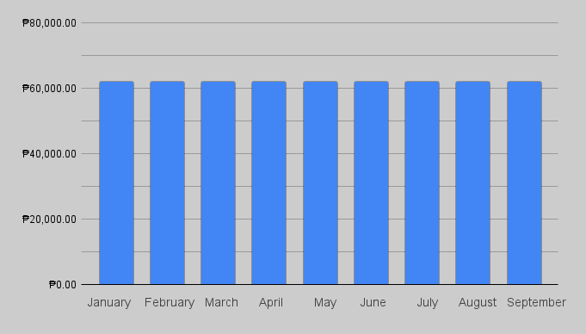

The table below shows the existing cost and the expenses of the developer of the existing online grading system.

**Table 3**

**Deployment Cost**

|  |  |
| --- | --- |
| **EXPENSES** | **COST** |
| **Developers Salary (Front end and Back end)** | **Php 40,000.00 monthly * 9 months = Php 360,000.00** |
| **Web Hosting** | **Php 3,108 for 1 year** |
| **Print Expenses** | **Php 100 for ink, Php 100 for Electricity = Php 200 * 9 months = Php 1,800.00** |
| **Bond Papers for Printing Documents** | **Php 100 * 9 months = PHP 900.00** |
| **Total = PHP 366,708.00** | |

The development cost is the breakdown of the expenses during the deployment of the website.

To calculate, the annual profit by subtracting the total cost of developing the current website from the total cost of the deployment. The annual profit is calculated as follows:

Development Cost ( **PHP** **567,972.00** ) - Deployment Cost ( **PHP 366,708** ) = **PHP 201,264.00**

The ROI or the Return on Investment of the total investment would be divided by the half-year profit which is **PHP 201,264.00**

ROI

TOTAL INVESTMENT

HALF YEAR PROFIT

According to this Calculation, the client will receive their investment back within 2-2.5 years.

**MOSCOW**

DEVELOPMENT OF AN ONLINE RECORDS MANAGEMENT SYSTEM FOR INTEGRATION

Must Have:

* User Login System with authentication
* Access Control for Admin and Teacher roles
* Standardized Grading Parameters across subjects or departments
* Automatic Grade Computation based on entered scores
* Grade Calculation Logic:

Prelim Grade: 100% based on Prelim scores

Midterm Grade: ⅓ from Prelim, ⅔ from Midterm scores

Final Grade: ⅓ from Midterm, ⅔ from

Final scores

* API Integration for real-time viewing of student grades
* Core Web Interface for inputting and viewing grades
* Basic Audit Trail to track changes in records

Should Have:

* Faculty User Accounts with restricted access
* Admin Panel for managing system users and parameters
* MIS Integration to synchronize student and course data
* Role-Based Dashboard (e.g., statistics for Admins and Teachers)

Could Have:

* Registrar Account Access
* Grade History Tracking
* Export Options
* Notification System

Won’t Have:

* Offline Excel Template download/upload feature for syncing during internet outages
* Built-in Security Testing Tools (e.g., penetration testing modules)
* Support for Primary and Secondary Level Grading Systems (Focus is on higher education or target-specific grading)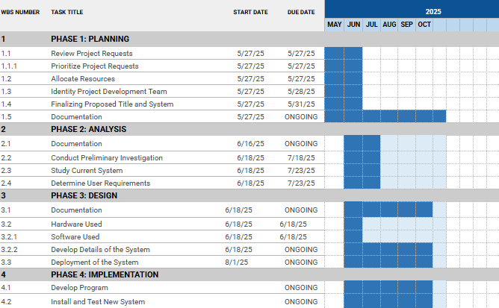

**Figure 4**

**Gantt Chart**

[**Gantt Chart (Grading System)**](https://docs.google.com/spreadsheets/d/1jUm9LfYEg_NZ0zivEbSwS_QzIe0voFL0x_8YZP0_97c/edit?usp=sharing)

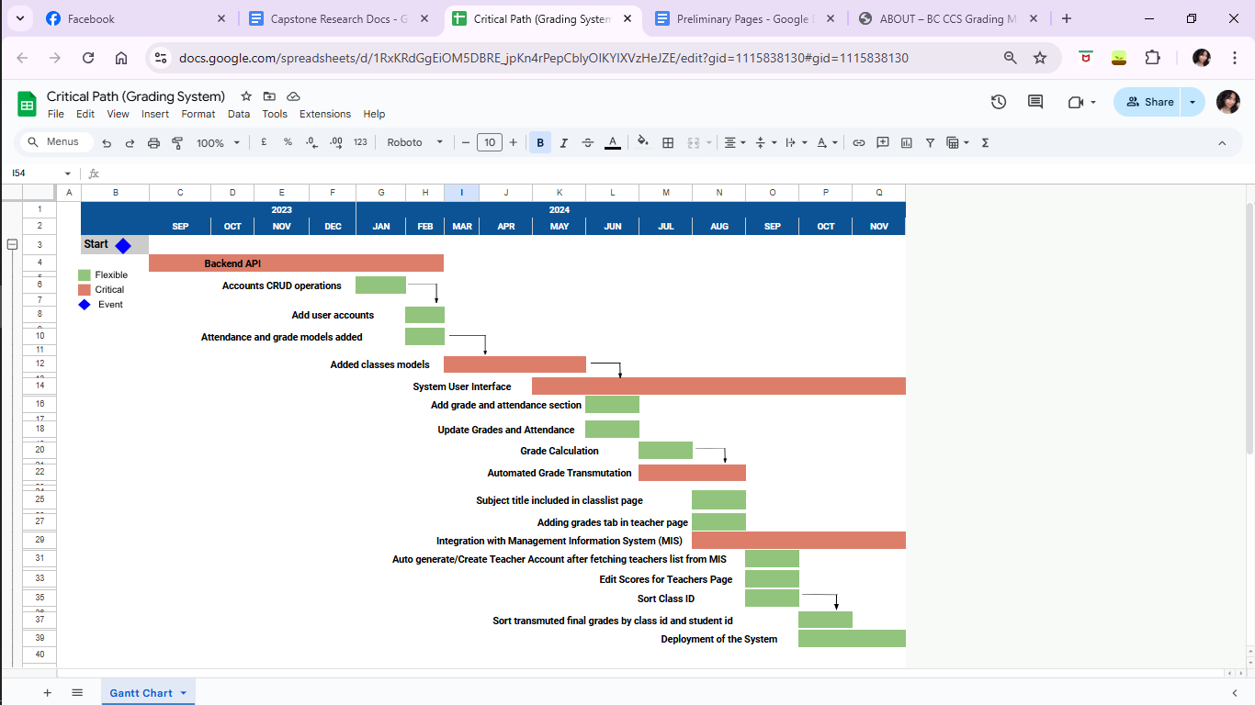

**Figure 5**

**Critical Path**

[**Critical Path (Grading System)**](https://docs.google.com/spreadsheets/d/1RxKRdGgEiOM5DBRE_jpKn4rPepCblyOIKYIXVzHeJZE/edit?usp=sharing)

**Data and Process Modeling**

The shift to digital technologies in today’s educational institutions has transformed how student records are managed, processed, and accessed. For the Automated Registrar Office System, data and process modeling played a vital role in the design and development of a structured, efficient, and user-friendly system that streamlines academic services at Benedicto College.

As part of this process, Data Flow Diagrams (DFDs) were created to visually represent the flow of information between different entities, processes, and data stores within the system. These diagrams serve as blueprints that help developers and stakeholders understand how the system operates from a functional perspective.

The modeling begins with a context diagram, which presents a high-level overview of the entire system as a single process and outlines its interaction with external entities such as students, registrar staff, and administrators. This top-level diagram establishes the system boundary and provides a clear picture of external inputs and outputs.

As the modeling progresses, Level 1 and Level 2 DFDs break down the system into more detailed processes, including student data retrieval, document request handling, transcript generation, and enrollment verification. These diagrams illustrate how data is input, processed, stored, and output at each step, offering a clear view of the system’s internal workflow.

Additionally, process modeling identifies the logical sequence of tasks, their dependencies, and the roles responsible for carrying them out. This helps ensure that the system’s implementation closely reflects the actual registrar office operations, reducing redundancy and improving process accuracy.

By using data and process modeling techniques, the development team was able to create a system that not only meets technical requirements but also aligns with real-world administrative functions. This ensures that the Automated Registrar Office System delivers consistent, accurate, and timely academic services to its users.

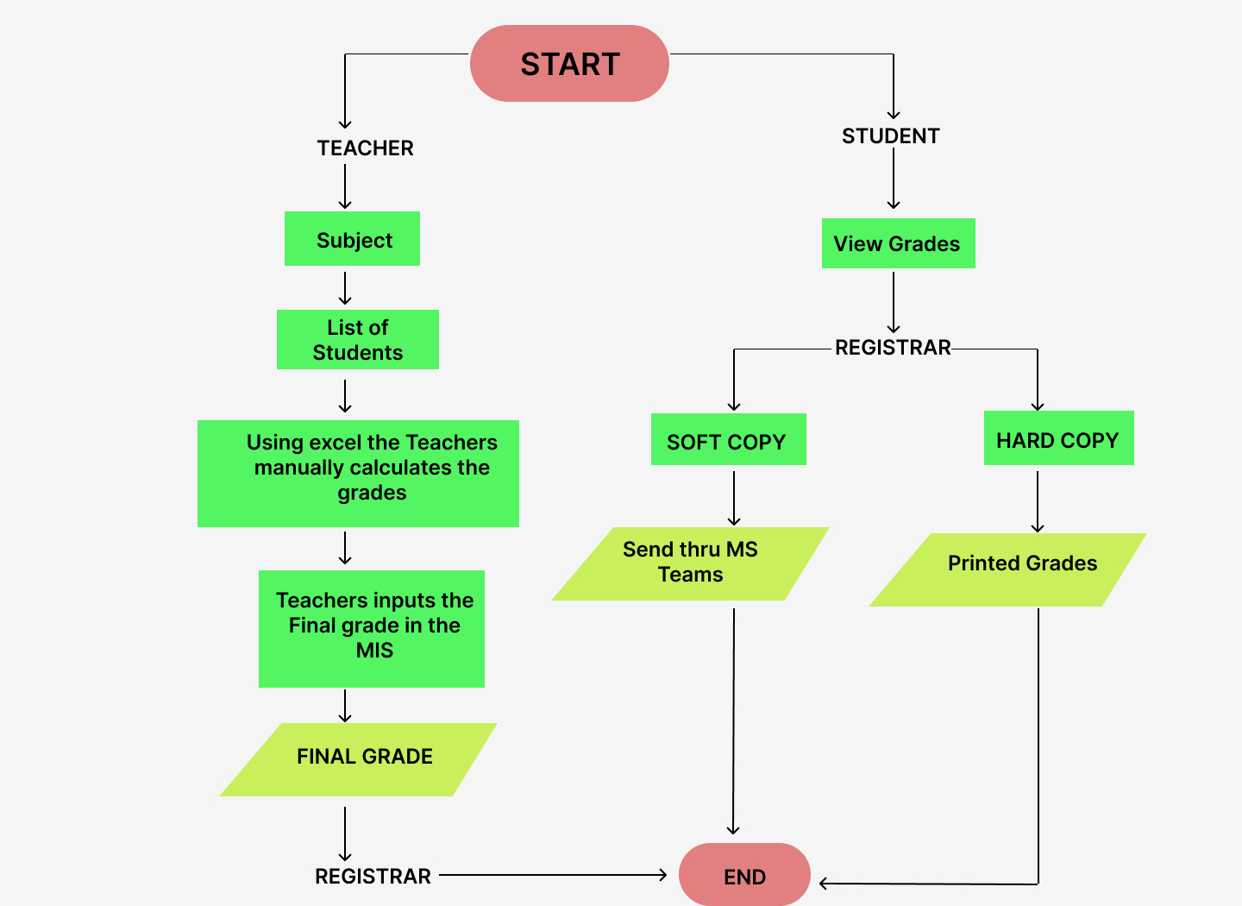

**Figure 6**

**Existing Flowchart**

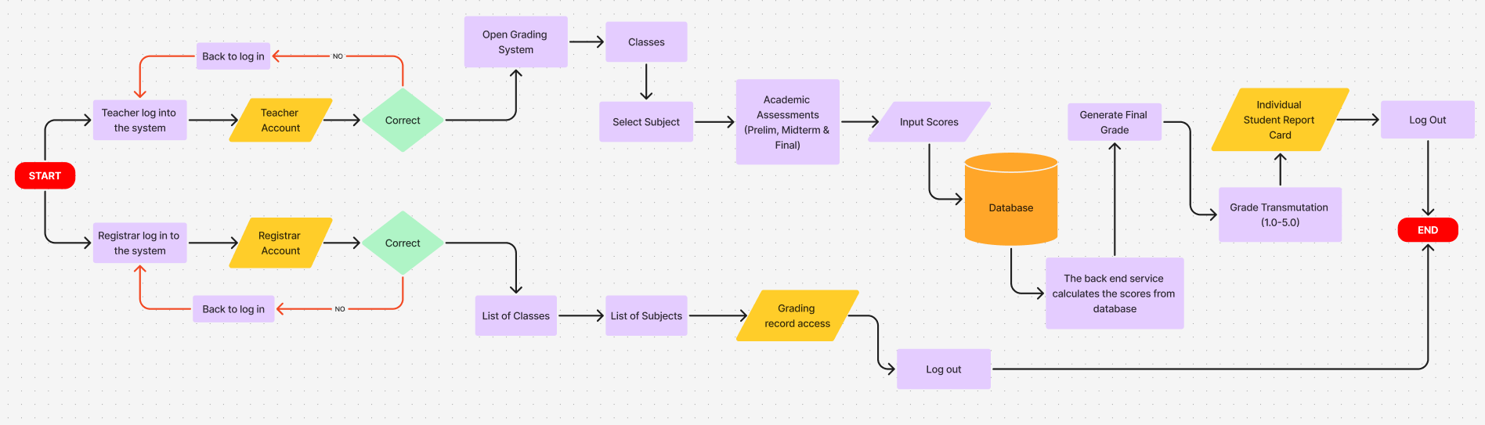

**Figure 7**

**Proposed Flowchart**

**Figure 8**

**Use Case Diagram**

**Narrative**

**Table 4**

**Log In**

|  |  |
| --- | --- |
| **Use Case:** | **Log In** |
| **Summary:** | **They should log in to the website to access the back end of the website** |
| **Actors:** | **Registrar, Accounting, Student** |
| **Purpose:** | **To access the back end of the website** |
| **Pre-Condition:** | **Enter credentials to log in** |
| **Post-Condition** | **Access the website** |
| **Exception:** |  |

|  |  |
| --- | --- |
| **FLOW OF EVENTS** | |
| **Actors Response** | **System Response** |
| 1. **Visit Website** | 1. **Display Website** |
| 1. **Click Login** | 1. **Display Login** |
| 1. **Enter Username and Password** | 1. **Successfully Login** |
| **ALTERNATIVE FLOW OF EVENTS** | |
| **5.1 If username/password is blank** | **5.2 Display Error** |
| **5.3 Username and Password is invalid** | **5.4 Incorrect Password or Username** |

**Table 5**

**Add Users**

|  |  |
| --- | --- |
| **Use Case:** | **Accounts** |
| **Summary:** | **Add user Accounts** |
| **Actors:** | **Admin / Registrar** |
| **Purpose:** | **Create Admin Accounts** |
| **Pre-Condition:** | **Admins has access to the website and details of the users.** |
| **Post-Condition** | **New user added** |
| **Exception:** |  |

|  |  |
| --- | --- |
| **FLOW OF EVENTS** | |
| **Actors Response** | **System Response** |
| 1. **Visit Website** | 1. **Display Website** |
| 1. **Click Login** | 1. **Display Login** |
| 1. **Enter Username and Password** | 1. **Successfully Login** |
| **ALTERNATIVE FLOW OF EVENTS** | |
| **5.1 If username/password is blank** | **5.2 Display Error** |
| **5.3 Username and Password is invalid** | **5.4 Incorrect Password or Username** |

**Table 6**

**Grading**

|  |  |
| --- | --- |
| **Use Case:** | **FOR GRADING** |
| **Summary:** | **Teachers can input Score Types (Attendance, Participation, Quiz, Project, Activity, 1 Major Exam Only) In each term (Prelim, Midterm, Final) In their classes or list of classes.** |
| **Actors:** | **Teachers** |
| **Purpose:** | **To input the scores in the parameters** |
| **Pre-Condition:** | **Teachers has access to the website and grade students** |
| **Post-Condition** | **Students Scores/Grades Added** |
| **Exception:** |  |

|  |  |
| --- | --- |
| **FLOW OF EVENTS** | |
| **Actors Response** | **System Response** |
| 1. **Visit Website** | 1. **Display Website** |
| 1. **Click Login** | 1. **Display Login** |
| 1. **Enter Username and Password** | 1. **Successfully Login** |
| **ALTERNATIVE FLOW OF EVENTS** | |
| **5.1 If username/password is blank** | **5.2 Display Error** |
| **5.3 Username and Password is invalid** | **5.4 Incorrect Password or Username** |

**Figure 9**

**Activity Diagram**

**Figure 10**

**State Chart Diagram**

**Design**

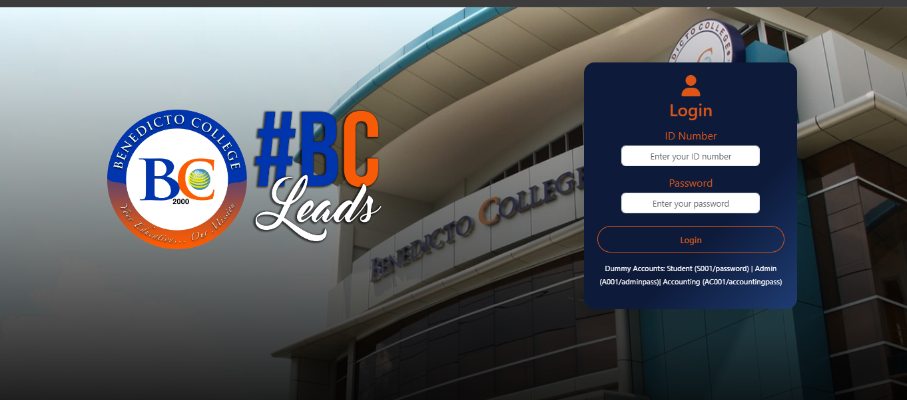

**Figure 11**

**Login Page (Admin and Teacher)**

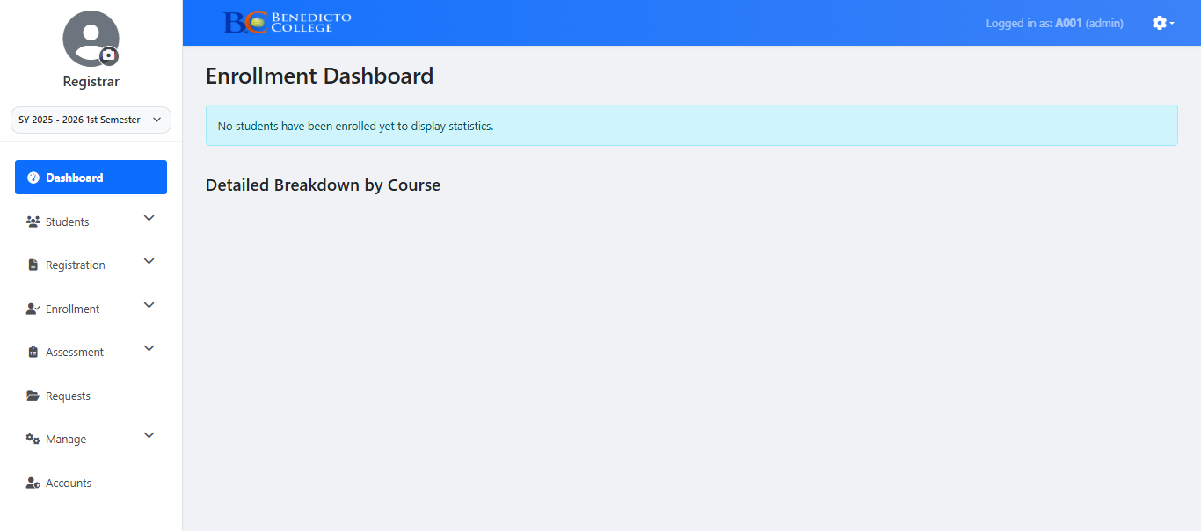

**Figure 12**

**Admin Dashboard**

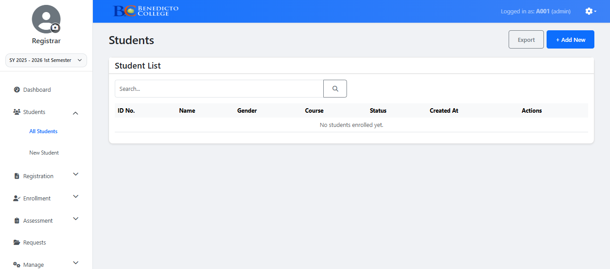

**Figure 13**

**View All Students**

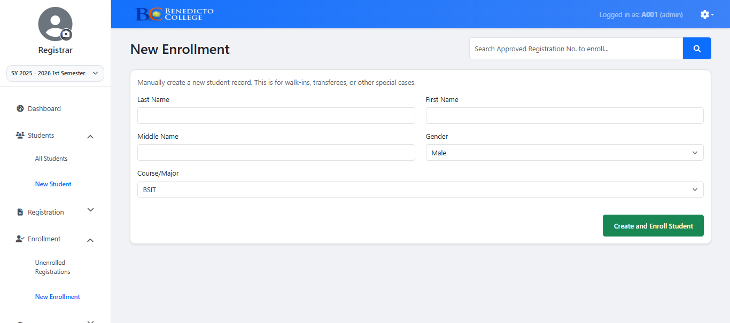

**Figure 14**

**Adding New Students**

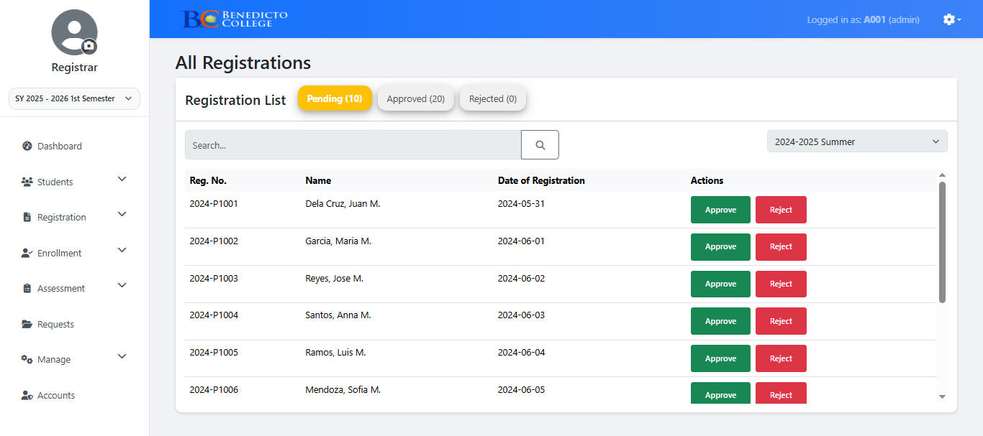

**Figure 15**

**Viewing All Students Enrolled**

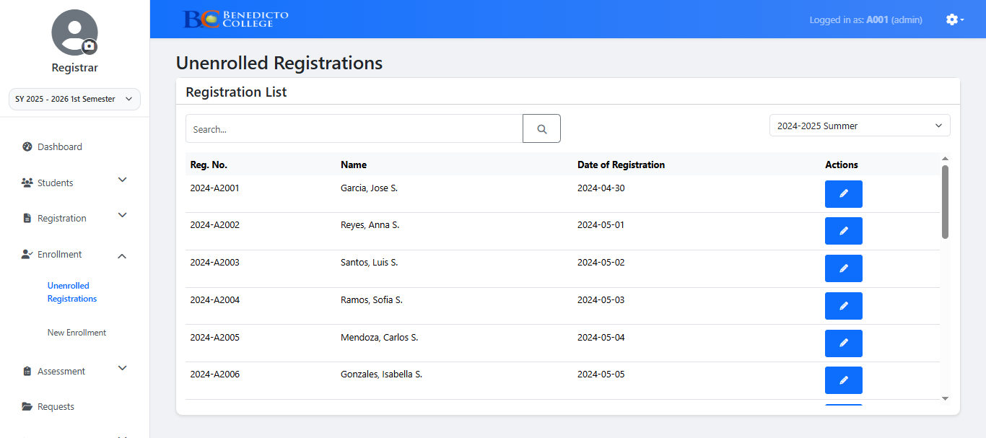

**Figure 16**

**View All Unenrolled Students**

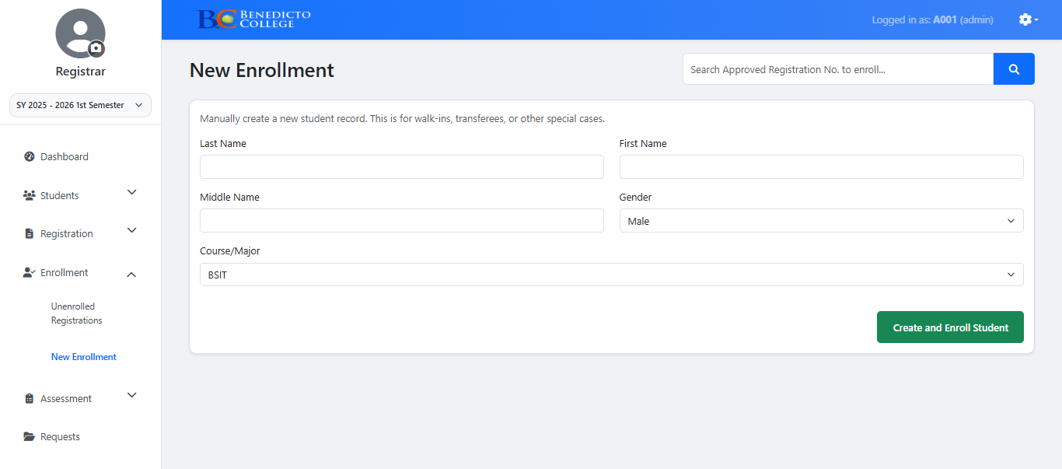

**Figure 17**

**Adding New Enrollees**

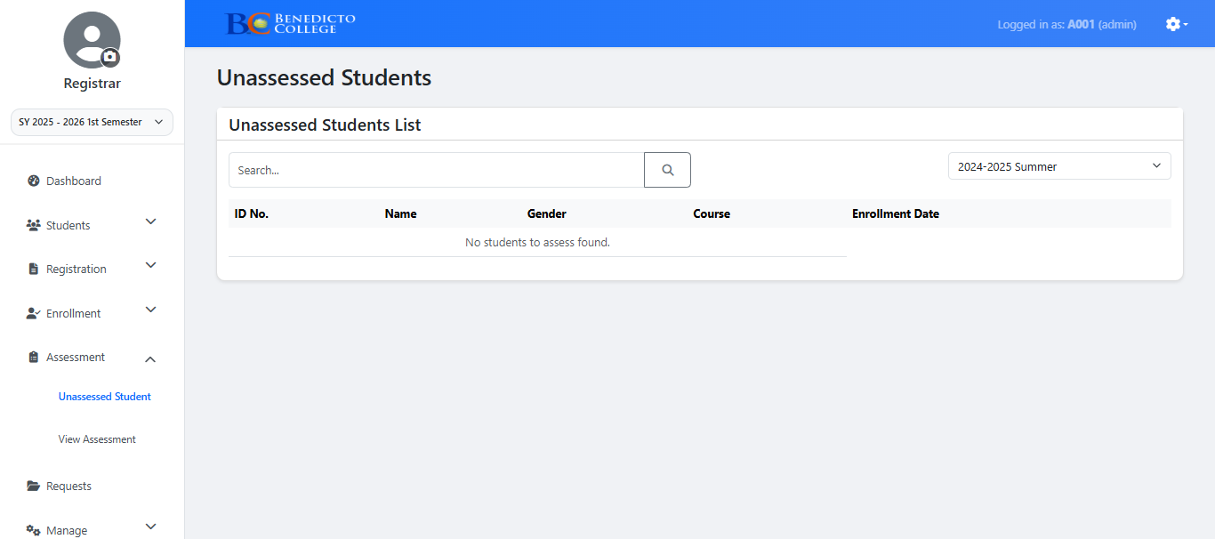

**Figure 18**

**View Unassessed Students**

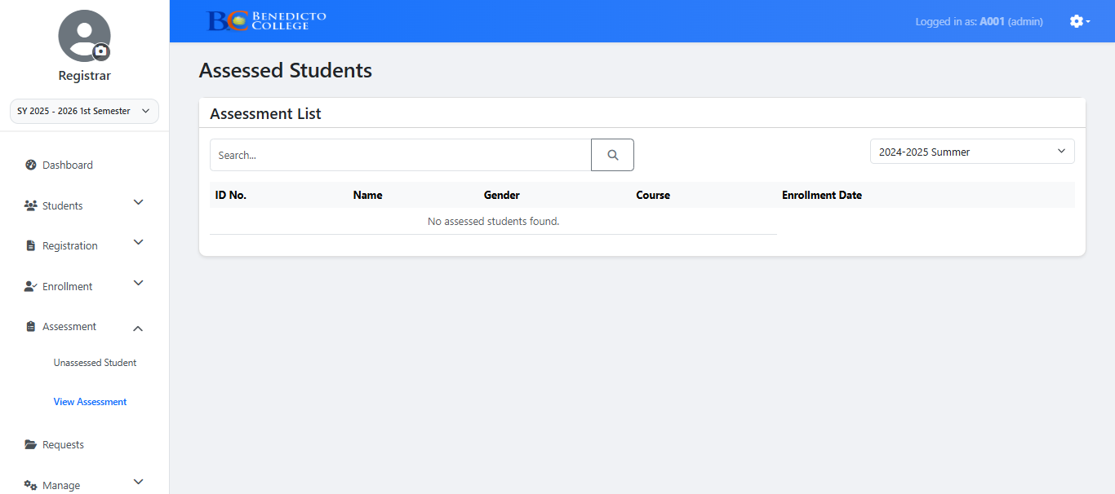

**Figure 19**

**View Student Assessment**

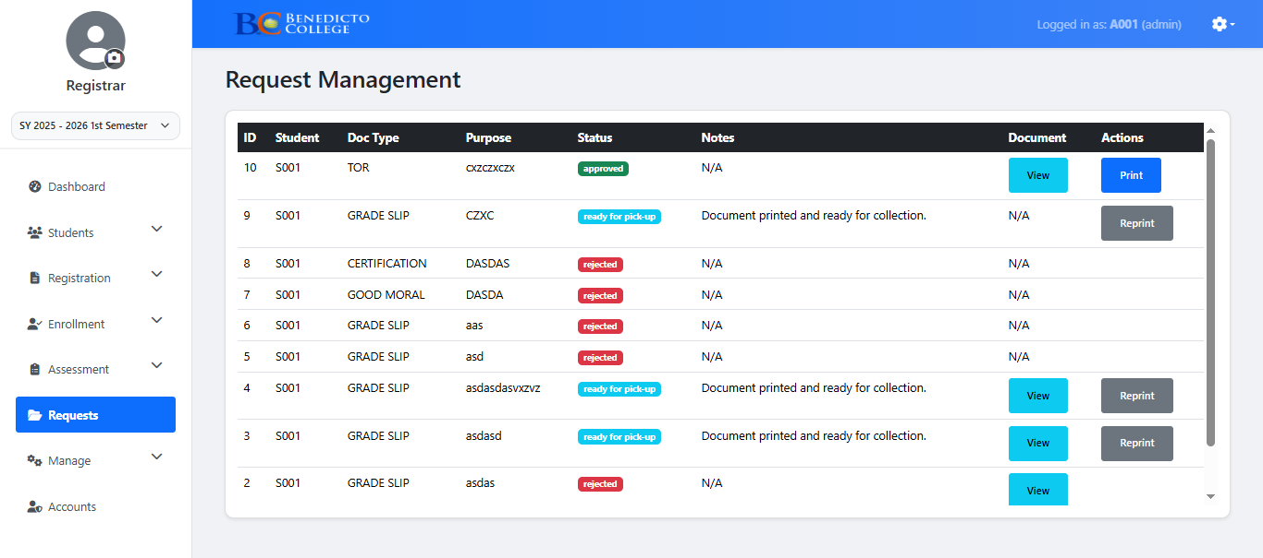

**Figure 20**

**Request Management Tab**

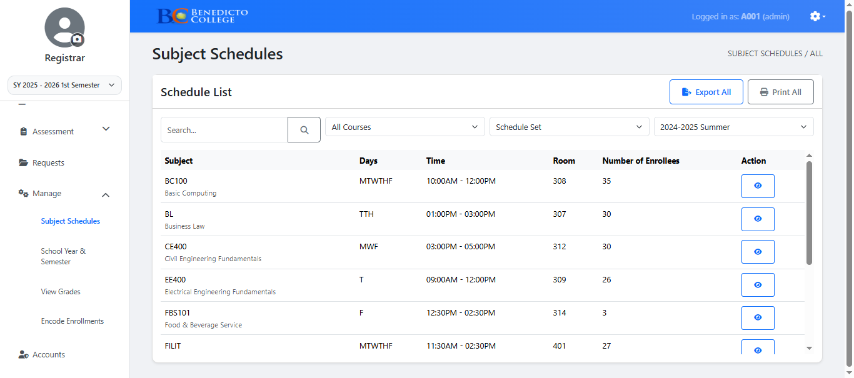

**Figure 21**

**View All Subjects Schedules**

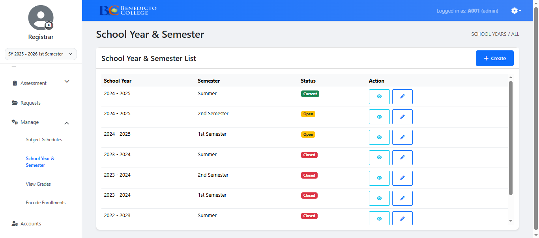

**Figure 22**

**Creating School Year & Semester**

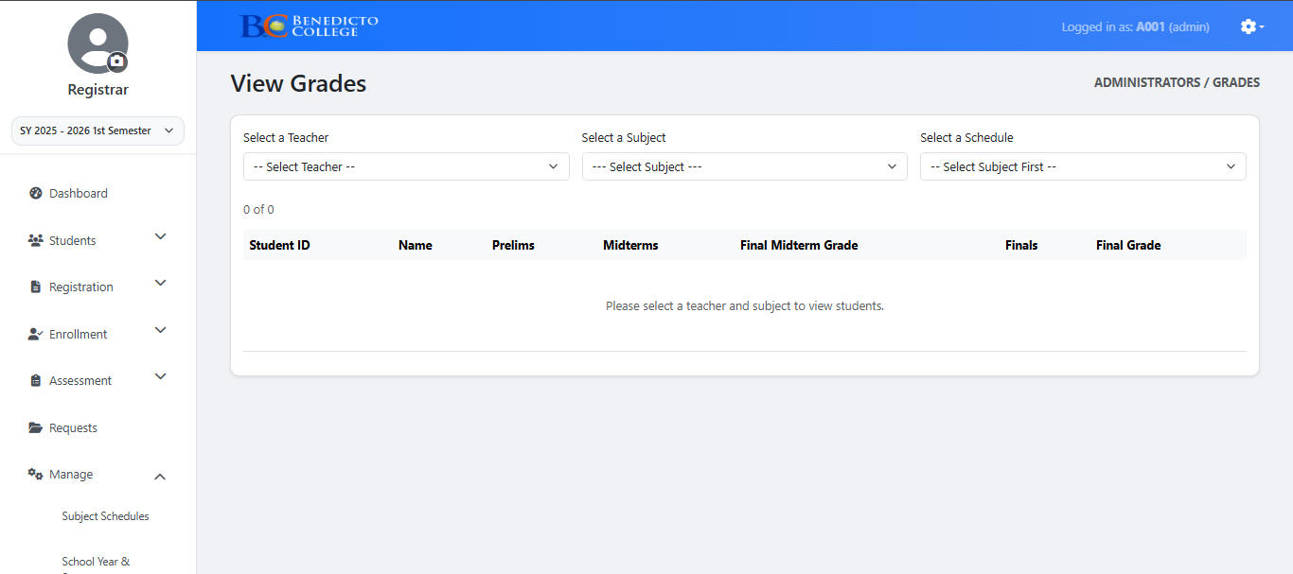

**Figure 23**

**View Grades**

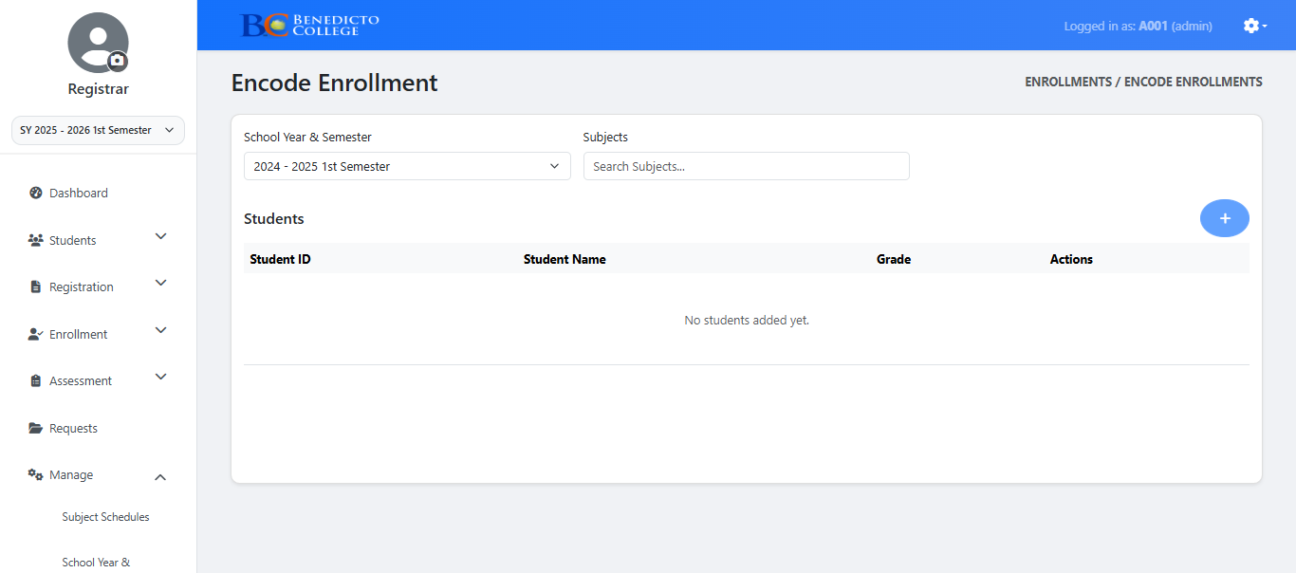

**Figure 24**

**Encoding Enrollments**

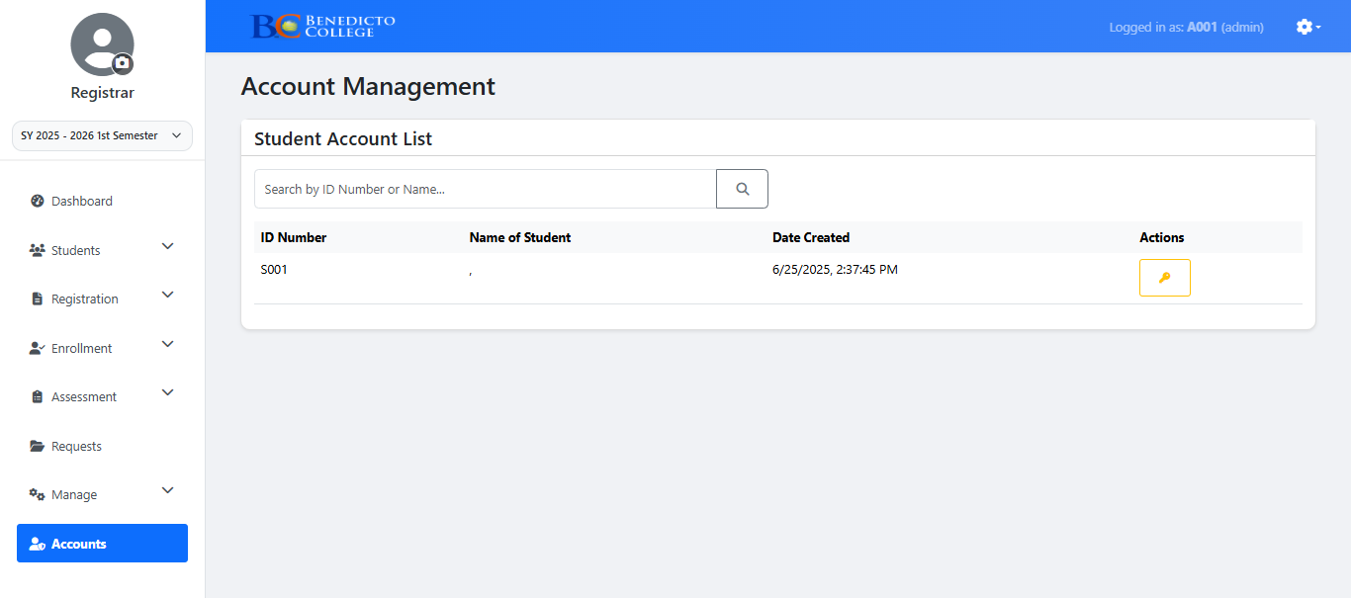

**Figure 25**

**Account Tab**

**Accounting Page**

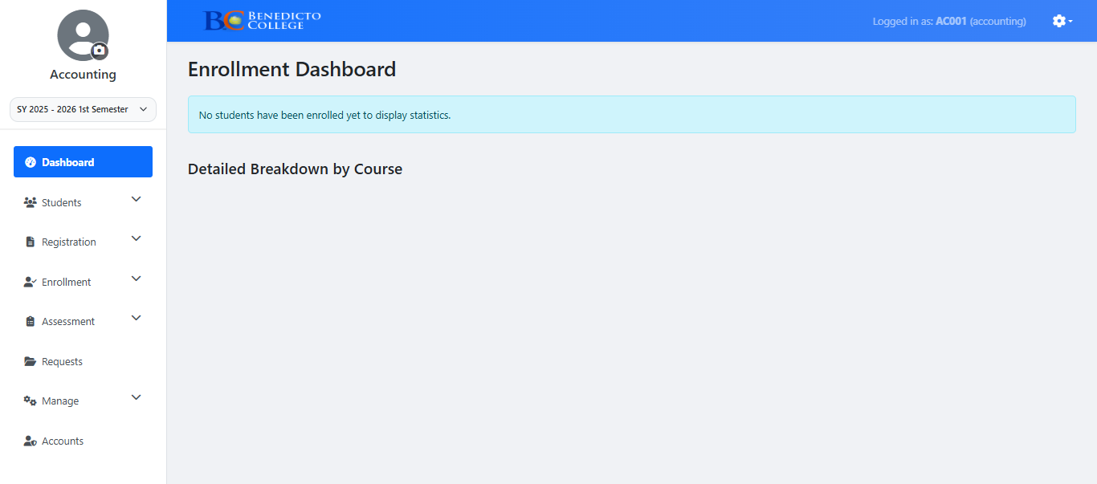

**Figure 26**

**Accounting Dashboard**

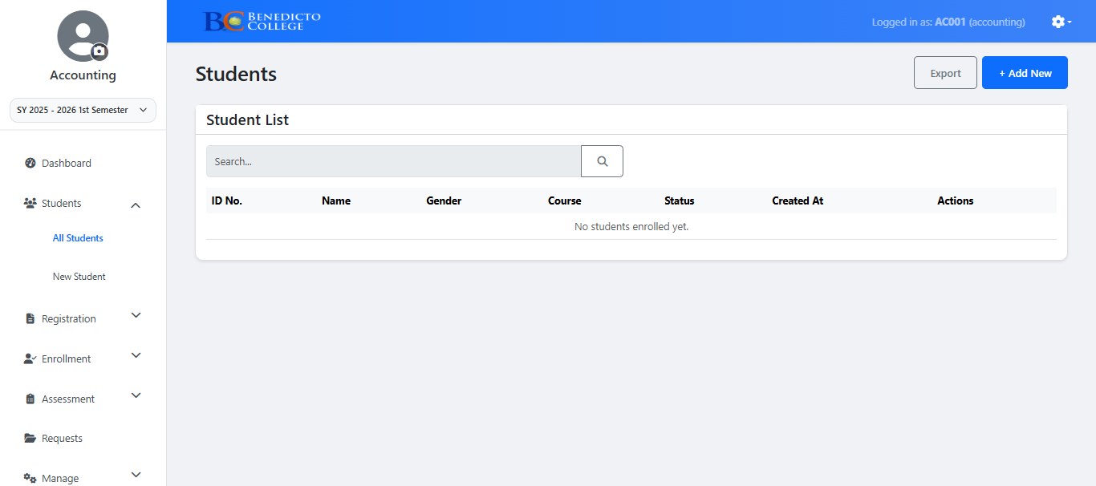

**Figure 27**

**Viewing All Students**

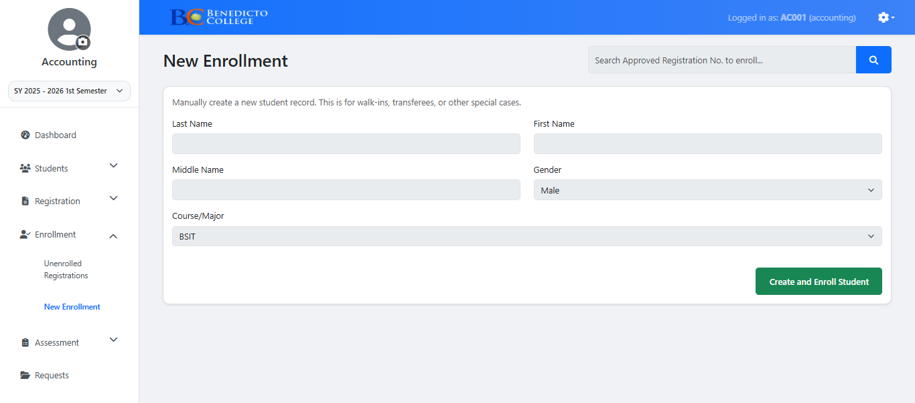

**Figure 28**

**Adding New Students**

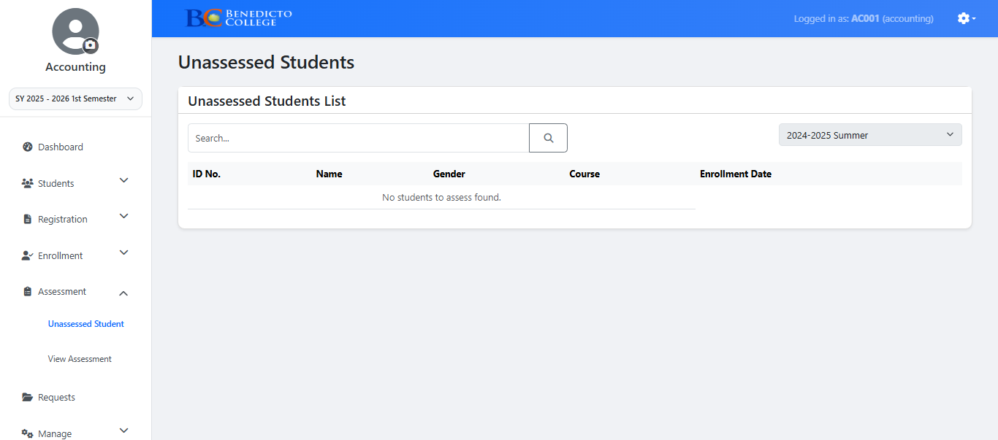

**Figure 29**

**Viewing Unassessed Students**

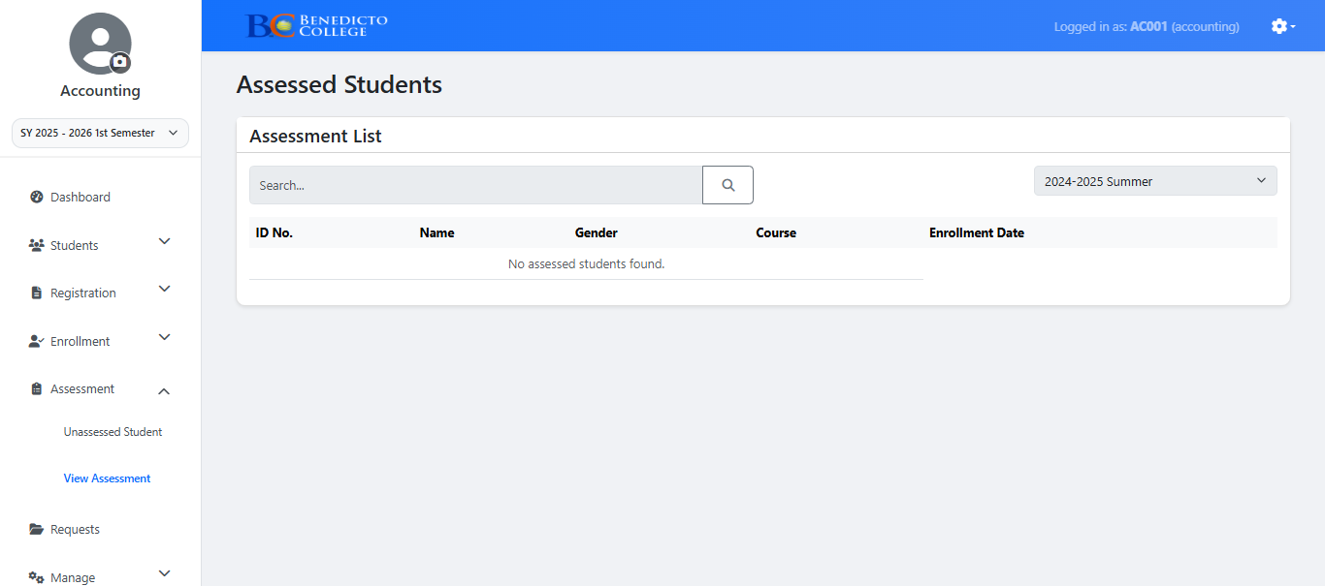

**Figure 30**

**View Student Assessment**

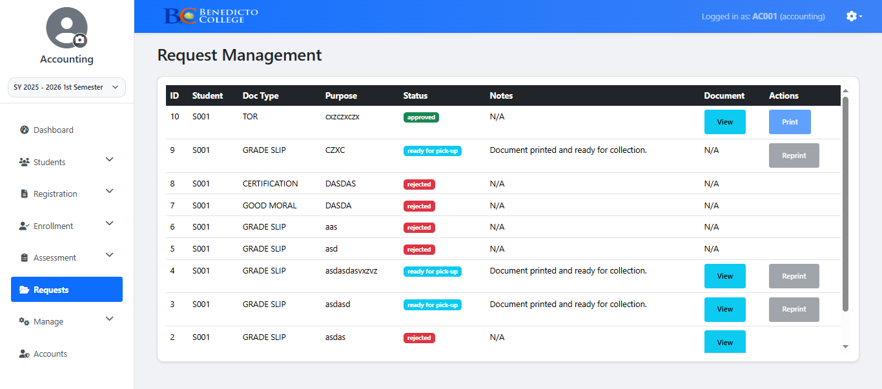

**Figure 31**

**Request Tab**

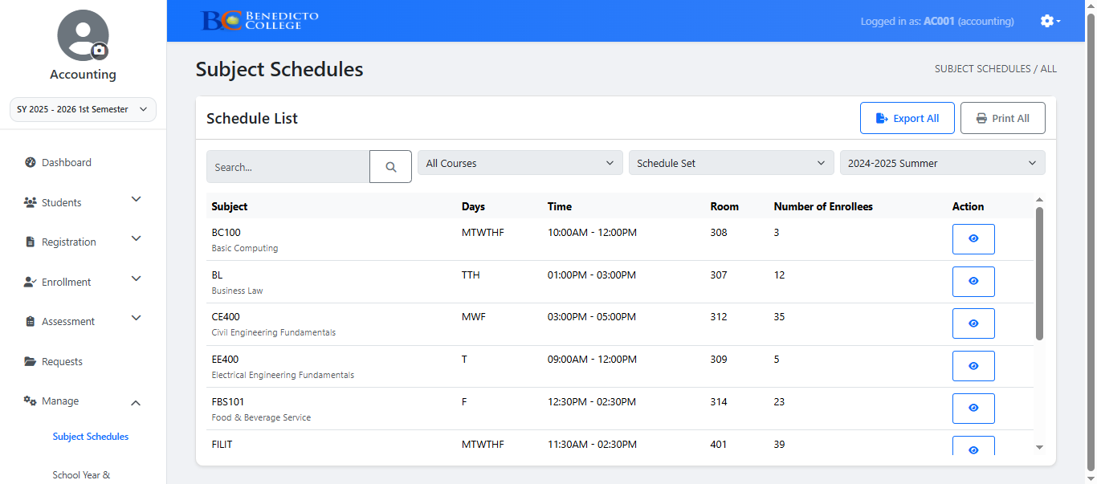

**Figure 32**

**View Subject Schedules**

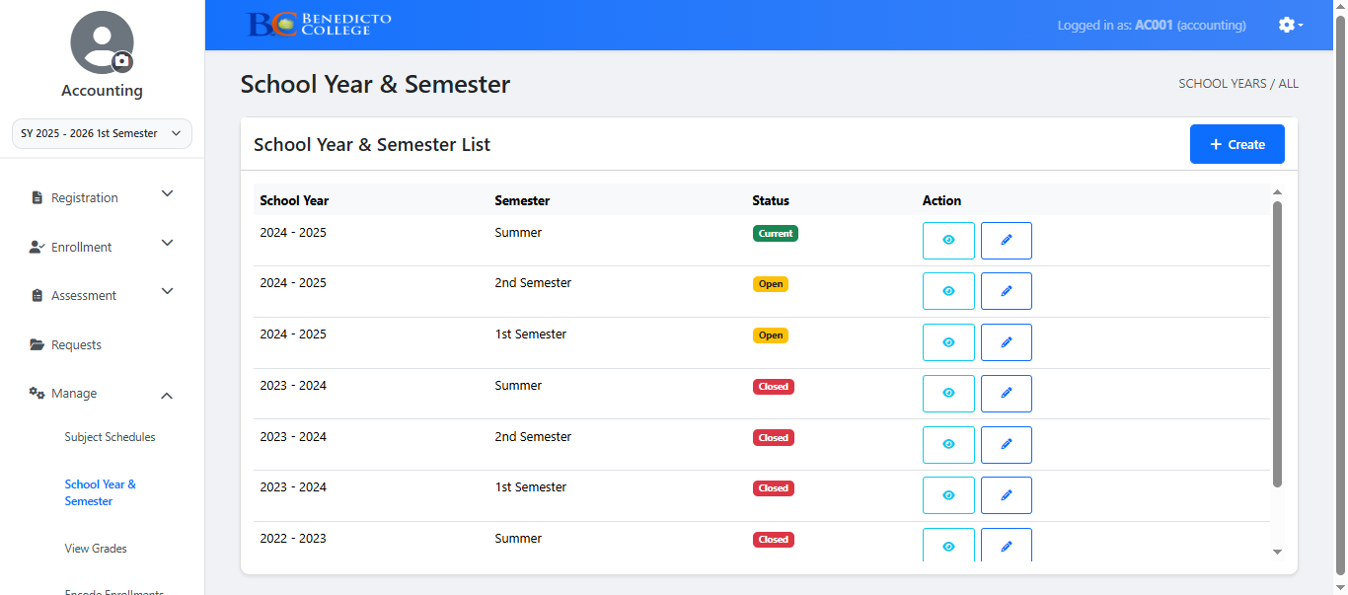

**Figure 33**

**Adding School Year & Semester**

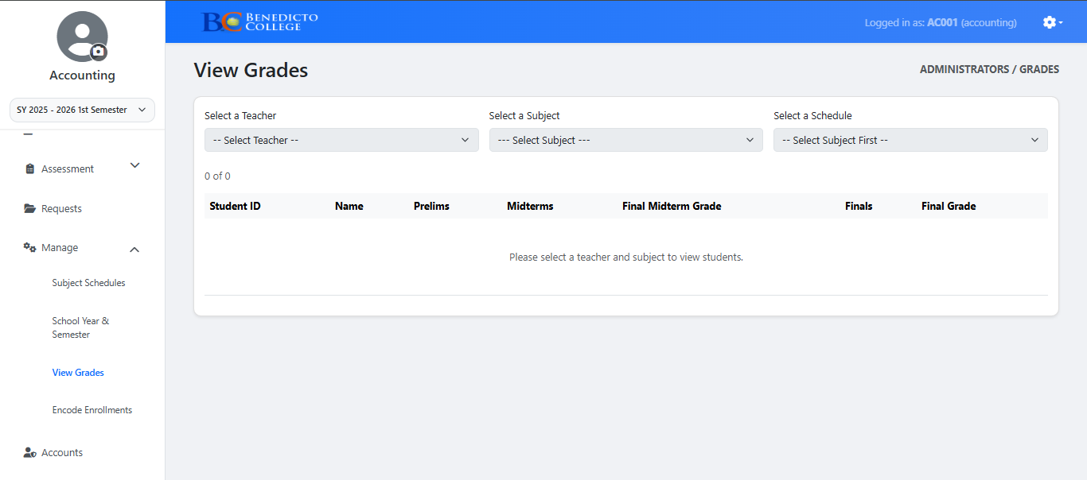

**Figure 34**

**View Grades**

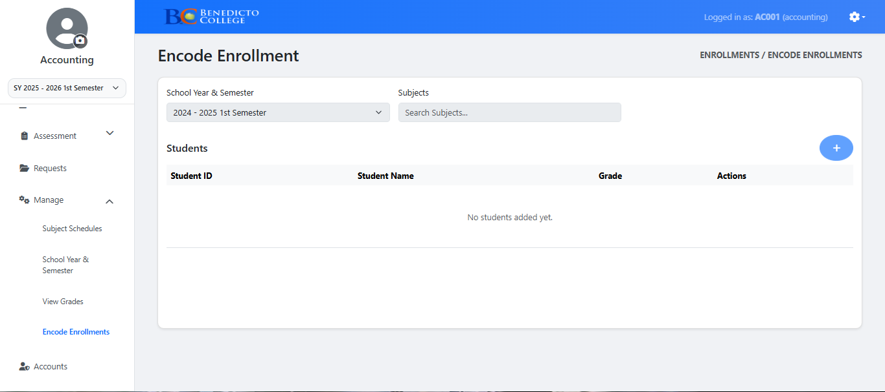

**Figure 35**

**Encoding Enrollees**

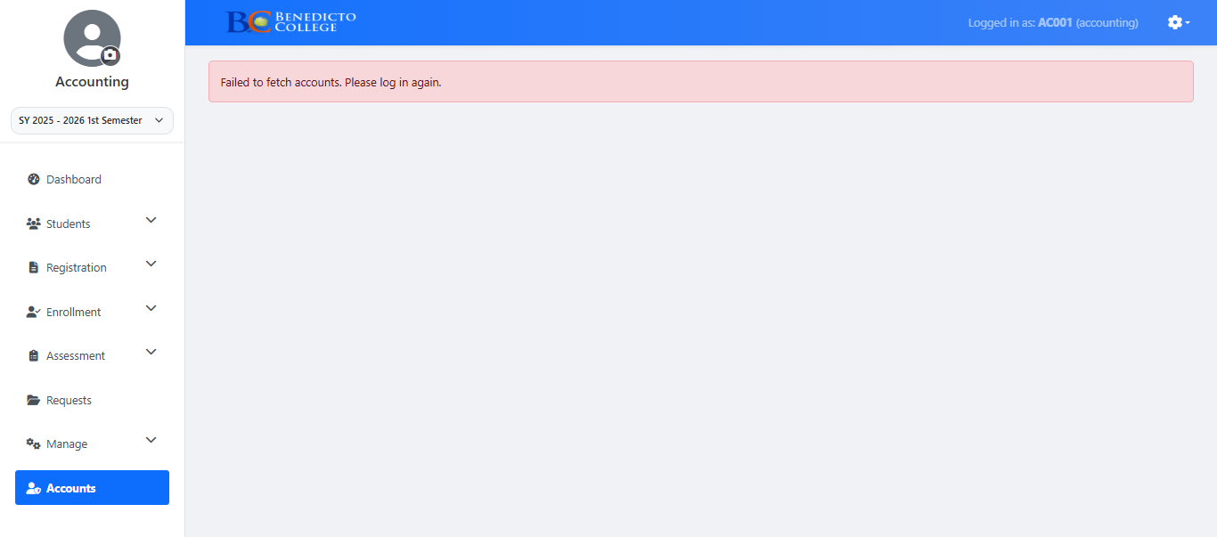

**Figure 37**

**Account Tab**

**Student Page**

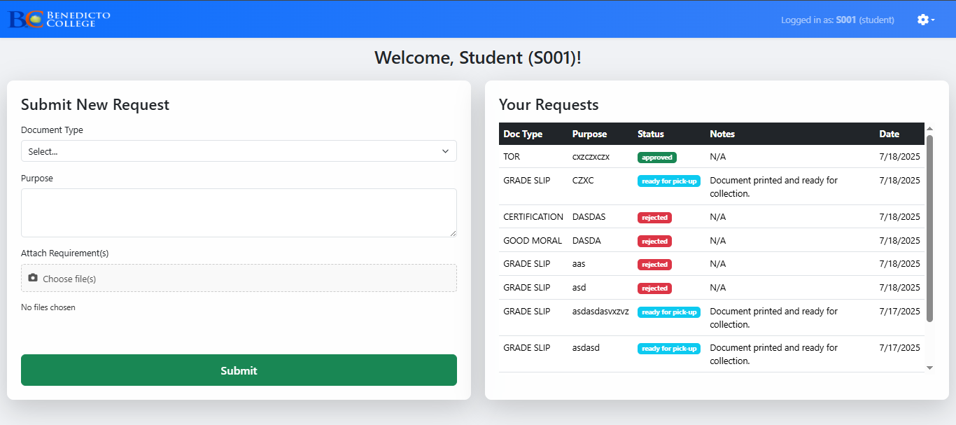

**Figure 38**

**Student Page**



**ADMINISTRATOR**

**ADMIN VISUAL**

**INTERFACE**

**TEACHER**

**USER**

**INTERFACE**

**WEB SERVER**

**DATABASE**

**Figure 26**

**System Architecture**

**Security**

Data security refers to the protection of digital information from unauthorized access, corruption, or theft throughout its lifecycle. In the context of the Automated Registrar Office System, data security is essential to protect sensitive academic records, including student profiles, grades, certifications, and document requests. Given the system's role in managing confidential information, multiple layers of security were implemented to ensure privacy, data integrity, and access control.

The following security measures were applied:

* **Authorization:** To protect personal academic data and uphold confidentiality, the system enforces role-based access controls. This ensures that only authorized users—such as registrar staff, faculty, and system administrators—can view or modify specific student records.
* **Data Backup:** Regular data backups are scheduled to protect against data loss due to system failures or accidental deletions. This allows for quick recovery and ensures the continuity of registrar operations, even in the event of technical disruptions.
* **Strong Password Policies:** Each user (admin, faculty, or staff) is required to use strong, complex passwords to reduce the risk of unauthorized access. These passwords are encrypted and stored securely in the system’s database, helping prevent breaches and misuse.
* **System Updates and Maintenance:** The system is designed with continuous security in mind. Regular updates are planned to patch vulnerabilities, optimize system performance, and align with emerging data protection standards such as the Philippine Data Privacy Act of 2012.

These security implementations are critical for maintaining trust, compliance, and operational integrity within the registrar’s office, ensuring that all student-related transactions remain secure and verifiable.

**Development**

A wide range of modern software tools and technologies were employed in the development of the Automated Registrar Office System for Benedicto College Main Campus. The primary Integrated Development Environment (IDE) used was Visual Studio Code (VS Code), which supported front-end and back-end development with features such as syntax highlighting, auto-indentation, debugging, and Git integration.

For the front-end interface, the system utilized HTML for structuring web pages, CSS for styling and layout design, and JavaScript for enabling dynamic and interactive features.

These technologies ensured that the system's user interface was intuitive and responsive across devices. To enhance the front-end development process, Bootstrap was integrated as the CSS framework, providing a mobile-first design approach and pre-built components that helped accelerate UI creation.

To handle client-side interactivity and performance, ReactJS was employed as the JavaScript library. React enabled the development team to build reusable UI components and maintain efficient rendering through its virtual DOM, ensuring a seamless and user-friendly experience for students and registrar staff.

The back-end development relied on Node.js for executing server-side code and Express.js to build RESTful APIs. This architecture allowed efficient handling of data requests, routing, and authentication processes. To improve code reliability and scalability, TypeScript was used as a statically typed superset of JavaScript, enhancing debugging and maintainability of the application.

For database management, the system used MySQL, a reliable and scalable relational database system suitable for handling complex student records. MySQL ensured data integrity and security for storing academic information. To bridge the gap between the application and the database, Sequelize ORM (Object-Relational Mapping) was implemented. Sequelize streamlined database operations such as record creation, updates, and retrieval, allowing developers to interact with the database using JavaScript rather than raw SQL.

Additional supporting tools included Postman, which was utilized for testing and verifying API endpoints during back-end development, and GitHub for version control and collaborative coding. The system was deployed using Netlify, a cloud hosting platform ideal for delivering static front-end applications with continuous integration from Git repositories.

Overall, the development approach prioritized security, scalability, and user-centric design, ensuring that the Automated Registrar Office System met the increasing demands of efficient academic record management and service delivery at Benedicto College.

**Hardware Specification**

In creating this system, an ASUS Vivobook X510UF with Windows 10 loaded was used to create the Online Grading System Capstone Project at Benedicto College Main Campus. The processor is a 1.60 GHz Intel Core i5-8250U. Two 8GB DDR4 2400MHz RAM sticks operating in dual channel mode make up the installed RAM, which has a total capacity of 16GB with 15.9GB of usable memory. With regard to storage, there is an additional 250 GB SATA SSD for storing files in addition to the 120 GB M.2 SSD that houses the operating system. The CPU is x64 based and runs a 64-bit operating system.

**Chapter 5**

**SUMMARY, CONCLUSION AND RECOMMENDATION**

**Summary**

The Automated Registrar Office System is a vital innovation aimed at transforming how academic records and student services are managed at Benedicto College. This capstone project, developed by Fourth Year Information Technology students at Benedicto College – Mandaue Campus, addresses the inefficiencies of the current manual system used by the Registrar’s Office. Through this study, the researchers identified critical issues such as data retrieval delays, record discrepancies, excessive paperwork, and heavy administrative workload. These problems hinder service delivery and compromise the accuracy and reliability of student records.

The primary goal of the project was to design and implement a centralized, web-based system that automates essential registrar functions including student record search, document issuance, and report generation. The system was developed using modern web technologies and incorporates best practices in data processing, records management, and user-centered design.

By transitioning from a manual to a digital platform, the system significantly reduces the likelihood of human error, improves data integrity, and enhances transparency and accessibility for students, faculty, and staff. The automation of routine registrar tasks also minimizes processing time and administrative burdens, thereby streamlining operations and improving overall institutional efficiency.

The study highlights not only the technical feasibility of the system but also its alignment with the long-term goals of Benedicto College in promoting operational excellence and digital transformation. Despite challenges such as user adaptation and infrastructure readiness, the Automated Registrar Office System stands as a scalable and sustainable solution for academic records management.

The scope of the study focused on tertiary-level records and core registrar operations, while limitations included the exclusion of financial transactions, chat features, and integration with broader institutional systems. Nevertheless, the system lays a strong foundation for future improvements and integration efforts.

In conclusion, this capstone project provides an effective, efficient, and future-ready solution to the long-standing challenges in the registrar operations of Benedicto College.

**Conclusion**

Through multiple phases of development, testing, and refinement, the researchers successfully created the Automated Registrar Office System, a digital solution designed to modernize and streamline the academic records management process at Benedicto College. The development journey involved careful planning, collaboration, and a strong commitment from the research team—particularly from those responsible for programming and system integration.

Although the process presented several technical and operational challenges, the final system offers a significant improvement over traditional manual methods. The Automated Registrar Office System automates key registrar functions such as student record searching, document requests, and report generation. Its user-friendly interface and centralized data handling reduce the risk of errors and delays, promoting both efficiency and accuracy in registrar operations.

The results of the implementation indicate notable improvements in administrative workflows, data retrieval speed, and overall user satisfaction. By digitizing records and enabling real-time access to academic information, the system supports better decision-making and provides faster service to students, faculty, and administrative personnel.

In conclusion, the Automated Registrar Office System not only meets its core objectives but also positions Benedicto College to embrace digital transformation in academic administration. The system represents a meaningful step forward in enhancing institutional efficiency, transparency, and service quality, and it holds potential for future expansion and integration across other departments.

**Recommendation**

Based on the findings and outcomes of the study, the researchers strongly recommend the institutional implementation of the Automated Registrar Office System at Benedicto College. The system offers a practical and efficient solution to the long-standing issues related to manual records management, document processing delays, and data inaccuracy. By adopting this system, the institution can significantly enhance service delivery, administrative efficiency, and user satisfaction for both students and staff.

However, as with any digital transition, the researchers recognize that some users—especially those unfamiliar with technology—may experience initial difficulties in adapting to the new platform. Therefore, it is recommended that the institution conduct comprehensive user training sessions for registrar staff, academic personnel, and relevant stakeholders. These sessions should focus on proper system navigation, data entry protocols, and troubleshooting procedures to ensure correct usage and encourage smooth adoption.

Additionally, the researchers suggest that the system be continuously evaluated and improved based on feedback from users. This includes enhancing functionality, updating features, and ensuring compatibility with future institutional systems such as the Management Information System (MIS) and enrollment platforms.

For students, the system’s efficiency in handling transcript requests, certification generation, and access to academic information will contribute to a more transparent and responsive educational experience. Therefore, student orientation programs or help guides should be made available to familiarize them with key features and processes.

In summary, successful implementation of the Automated Registrar Office System—along with proper training, support, and continuous improvement—will greatly benefit Benedicto College’s academic community and serve as a foundation for broader digital transformation initiatives.

**DEFINITION OF TERMS**

**Accuracy –** The quality of being correct and free from error; in the context of the system, it refers to the correctness of student records and document processing.

Automated – Designed to operate with minimal human intervention; refers to systems or processes performed by software rather than manually.

**Centralized Database –** A unified digital storage system that consolidates all student records and makes them accessible through a single platform.

Compatibility – The ability of the system to work efficiently with existing technologies such as MIS, enrollment systems, or grading modules.

**Confidentiality –** A security measure ensuring that student information is only accessible to authorized users.

**Consistency –** The reliability of processes and data, ensuring that services and outputs remain accurate and standardized over time.

**Data Analysis –** The process of examining data systematically to extract useful information, often used in improving registrar processes and decision-making.

**Data-Driven –** A decision-making approach based on factual information stored and processed within the system.

**Data Integrity –** The accuracy and consistency of stored data, maintained through validation and secure database handling.

**Data Retrieval –** The process of accessing and displaying information from a database, particularly student academic records and history.

**Discrepancies –** Inconsistencies in data, such as mismatched student records or incorrect entries, often caused by manual handling.

**Efficiency –** The ability to achieve maximum productivity with minimum wasted effort or resources; in this system, it means faster processing of student records and services.

**Empirical Study –** A research approach involving observation and data collection to support system development and recommendations.

**Feasibility –** The practicality and suitability of the system for implementation within Benedicto College.

**Information Processing –** A method of handling data input, storage, and output, applied in the system to manage registrar tasks digitally.

**Operational Feasibility –** A measure of how well the system fits within existing administrative workflows and how easily staff can adopt it.

**Outdated –** Refers to the existing manual system currently in use, which lacks efficiency and digital functionality.

**Records Management –** The systematic control of student information throughout its life cycle, including collection, access, storage, and disposal.

**Real-Time –** Instant access and updates to student information without delay, as facilitated by the automated system.

**Reliability –** The ability of the system to consistently perform its intended functions without failure.

**Report Generation –** The automated creation of documents such as transcripts, certificates, and academic summaries based on stored student data.

**Scalability –** The capacity of the system to grow and adapt to increasing student data or expanding institutional needs.

**Security –** Protective measures implemented to prevent unauthorized access to academic data and ensure data privacy.

**Self-Service –** A system feature that allows students to request documents or view academic information without going through manual steps.

**Stakeholders –** Individuals or groups who are affected by or benefit from the system, such as students, registrar staff, faculty, and administrators.

**System Integration –** The process of connecting the automated registrar system with other institutional systems for seamless operation.

**Transparency –** The system’s ability to provide clear and accessible information regarding student records and registrar transactions.

**User Adaptation –** The process by which users adjust to and become proficient with the new digital registrar system.

**User-Friendly Interface –** A system design that prioritizes ease of navigation and usability for both registrar staff and students.

**References**

Bagacay, I. R. V., Talatala, E. A., & Soberano, K. T. (2024). *Streamlining school registration: An innovative automated system for registrars.* Retrieved from <https://ijcsmc.com/docs/papers/April2024/V13I4202404.pdf>

Berry, R.M. (n.d.). *Queuing theory.* Retrieved from <https://www.whitman.edu/documents/academics/mathematics/berryrm.pdf>

Buckland, M. (n.d.). *On the nature of records management theory.* Retrieved from <https://people.ischool.berkeley.edu/~buckland/rmtheory.html>

Dela Rosa, A. P. M. (2022). *Web-based management information system of cases filed with the National Labor Relations Commission.* Retrieved from <https://arxiv.org/abs/2211.14452>

Doctor, A. C. (2022). *Integrated educational management tool for Adamson University.* *American Journal of Multidisciplinary Research & Innovation.* Retrieved from <https://journals.e-palli.com/home/index.php/ajmri/article/view/447>

John, B. (2024). *A computerized students' records management system: A case study of Faculty of Science and Technology, Kampala International University Western Campus.* Retrieved from <https://afribary.com/works/a-computerized-students-records-management-system>

Libadia, M., Botangen, K. A., Lucero, P. J., & Tecson, J. (2025). *Development of a web-based records management system: An ERMS initiative for the Office of Senior Citizen Affairs in the Philippines.* *Records Management Journal.* Retrieved from <https://www.emerald.com/insight/content/doi/10.1108/rmj-06-2023-0031/full/html>

Lewin’s Change Model. (n.d.). *Understanding organizational change.* Retrieved from <https://whatfix.com/blog/lewins-change-model/?fbclid=IwY2xjawIiuO5leHRuA2FlbQIxMAABHW-o4XYOiWU2oPOCzrsHxFtIPIhumxGYTeshEGSOSJ1e1Ml3XUNgepwGhg_aem_k_MlPpXzjzb3Ic03JFyEjw#:~:text=One%20of%20the%20most%20influential,unfreezing%2C%20changing%2C%20and%20refreezing>

Mamo, R. (2020). *Service-oriented computing for effective management of academic records: In case of Debre Markos University Burie Campus.* *International Journal of Modern Education and Computer Science (IJMECS).* Retrieved from <https://www.mecs-press.org/ijmecs/ijmecs-v12-n4/v12n4-5.html>

Mallari, M. L. Z., Guintu, J. S., Magalong, Y. C., & Yap, D. S. (2022). *CLIQUE: A web-based queue management system with real-time queue tracking and notification of units for Angeles University Foundation Office of the University Registrar.* *Proceedings of the 2022 Istanbul International Conference.* Retrieved from <https://ieomsociety.org/proceedings/2022istanbul/359.pdf>

Marienel, N. V., Cabrera, R. Z., Palma, J. B., & Jerwin. (2024). *Streamlining academic document requests: Leveraging an online management system.* *IEEE Xplore.* Retrieved from <https://ieeexplore.ieee.org/document/10778819>

Technology Acceptance Model (TAM). (n.d.). *Understanding user adoption of technology.* Retrieved from <https://open.ncl.ac.uk/theories/1/technology-acceptance-model>

Velasco, M. N., Cabrera, R. Z., Palma, J. B., & Jerwin. (2024). *Streamlining academic document requests: Leveraging an online management system.* Retrieved from <https://ieeexplore.ieee.org/document/10778819>\

Zaragosa, R. A. (2021). *Registrar information system through SMS.* *International Journal of Multidisciplinary Research and Analysis.* Retrieved from <https://www.academia.edu/download/103388871/21.pdf>

Las Johansen B. Caluza (2017) Development of Electronic Document Archive Management System (EDAMS): A Case Study of a University Registrar in the Philippines. Retrieved from <https://www.academia.edu/34911478/DEVELOPMENT_OF_ELECTRONIC_DOCUMENT_ARCHIVE_MANAGEMENT_SYSTEM_EDAMS_A_CASE_STUDY_OF_A_UNIVERSITY_REGISTRAR_IN_THE_PHILIPPINES>

Iris Ruthzelle V. Bagacay, Edsel A. Talatala, Kristine T. Soberano (2024) Streamlining School Registration: An Innovative Automated System for Registrars. Retrieved from <https://scholar.google.com/scholar?as_q=Streamlining+School+Registration%3A+An+Innovative+Automated+System+for+Registrars&utm_medium=researchbib>

Zaragosa, A. (2021). *Registrar Information System through SMS*. Retrieved from <https://d1wqtxts1xzle7.cloudfront.net/103388871/21-libre.pdf>

Velasco, Resylyn Z. Cabrera, James Benedict M. Palma, Jerwin (2024) Streamlining Academic Document Requests: Leveraging an Online Management System. Retrieved from <https://ieeexplore.ieee.org/abstract/document/10778819>

Dinalyn Mallares, Wayne Custer Alegata, Joel M. Bual (2024) Admission and Registrar Office (ARO) Mobile Document Scanner with Archiving System. Retrieved from

<https://techniumscience.com/index.php/technium/article/view/10957>

Bagacay, I. R. V., Talatala, E. A., & Soberano, K. T. (2024). *Efficiency of automated registration systems in education*. Retrieved from <https://d1wqtxts1xzle7.cloudfront.net/113209598/V13I4202404-libre.pdf>

Contreras, S., & Contreras, E. (2023). *Automated Systematized Enrollment Program* Retrieved from <https://d1wqtxts1xzle7.cloudfront.net/99773861/10011311120214159-libre.pdf>

Wagan, M. A. A., Briones, J., Baldovino, F. P., & Refozar, R. F. G. (2025). Digital transformation in the records management of a private higher education institution in the Philippines. *International Journal of Marketing and Digital Creative, 3*(1), 18–33. Retrieved from <https://www.proquest.com/docview/3194094586>

**Recommendation:**

- Enhancement of the Existing Institutional MIS specifically the Student Records

Management Department

- Integration of the Student Records Management System with the Existing

Institutional MIS

- Enhancement of the Institutional MIS

- Integration of the Records Management System

- Readyness of the MIS

- Readyness of the School Records Management System for Integration to the MIS

- Development an Online Records Management System for Integration of MIS

- - Development an Online Records Management System for Integration

PROBLEM:

- Retrieval which cause delay processing and heavy workload

- Data Entry

1. Data Retrieval

2. Report Generation

3. Processing

* Bullet the problem

OBJECTIVE:

- To develop the searching functionality that can allow

passed and accurate search

- To develop a searching functionality that can allow the user

to search student records by student or __ to minimize

GENERAL OBJECTIVE

- The primary objective of the study that is to develop a student record a

automated records management system (give the purpose)

*The problem should be sync to the Title*

SPECIFIC OBJECTIVE:

- Search functionality that will allow the user to ___ the student ID

**APPENDICES**

**APPENDIX A**

**RELEVANT SOURCE CODE**

**APPENDIX B**

**TEACHER**

**ADMINS**

Login

View Grades

Create User

Add User Role

View User List

Modify Users Account

Logout

View List of Students

Subject List

Semester

S.Y List

Login

Grade Students

View Grades

Logout

**Figure 27**

**Users Guide**

**APPENDIX C**

**GRAMMARIAN’S CERTIFICATE**

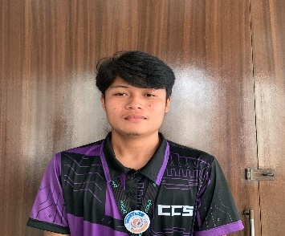**CURRICULUM VITAE**

MARK ANTHONY AÑASCO

Pusok Lapu-lapu City, Cebu Philippines 6015

0960-865-3930

[markanasco55@gmail.com](mailto:markanasco55@gmail.com)

Hi! I'm Mark Añasco, a passionate Frontend Developer from Cebu, Philippines, with expertise as a Web Designer, Developer, and WordPress Developer. I specialize in building visually appealing and user-friendly interfaces using my technology stack. My strengths include attention to detail and ability to deliver seamless user experiences. I stay up-to-date with the latest trends and use tools such as Figma. Additionally, I excel in utilizing development platforms such as WordPress to create engaging.

**EDUCATION**

**Senior High School Benedicto College**

**Diploma** Bachelor Of Science in Information Technology

Advance Institute Of Technology (2021-Current)

(2020 - 2021)

**TECHNICAL SKILLS**

* HTML5
* CSS3
* Javascript
* Bootstrap
* WordPress
* Figma
* Windows

**WORK SKILLS**

* Knowledge bootstrap and media queries for mobile responsive
* knowledge into design and creation of user interfaces
* Up-to-date with the latest web design techniques and trends
* Knowledge in WordPress development
* Knowledge about APIs, with an understanding of HTTP methods like GET, POST, PUT, and DELETE.
* Maintenance
* Operation Management
* Customer Service

**CERTIFICATIONS AWARDS**

**Supreme Student Council |** BENEDICTO COLLEGE

**2022**-(MAIN CAMPUS)

**PSITE Central Visayas |** ICT STUDENT CONGRESS - CEBU

**2023** - (CTU MAIN CAMPUS)

**Supreme Student Council |** BENEDICTO COLLEGE

**2024**-(MAIN CAMPUS)

**PSITE Central Visayas |** ICT STUDENT CONGRESS - CEBU

**2024** - (CTU MAIN CAMPUS)

PETER YARES

Canjulao Lapu-lapu City, Cebu Philippines 6015

0995-324-3189

peteryares12345@gmail.com

Detail-oriented Web Designing & Editor adept at making critical decisions, managing deadlines and conducting team reviews. With expertise in analysis and quantitative problem-solving skills, dedicated to company growth and improvements and also can be flexible for any job offered willing and eager to pursue the opportunity given.

**EDUCATION**

**Senior High School Benedicto College**

**Diploma** Bachelor Of Science in Information Technology

Asian Learning Center (2021-Current)

(2020 - 2021)

**TECHNICAL SKILLS**

* Web Design

**WORK SKILLS**

* Creative Thinking
* Critical Thinking
* Management
* Teamwork

**CERTIFICATIONS AWARDS**

**PSITE Central Visayas |** ICT STUDENT CONGRESS - CEBU

**2023** - (CTU MAIN CAMPUS)

**PSITE Central Visayas |** ICT STUDENT CONGRESS - CEBU

**2024** - (CTU MAIN CAMPUS)

Eliakim Malubay Aranza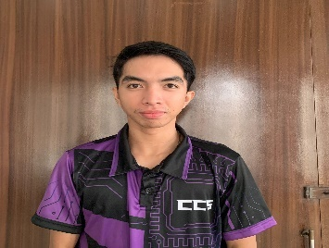

Liko-an Marigondon Lapu-Lapu City

0994-564-1400

[**slap.kimyt@gmail.com**](mailto:slap.kimyt@gmail.com)

Dedicated individual who successfully balances the demands of being a student-athlete. As a BSIT student, I am passionate about technology and strive to excel academically, networking, and IT systems. At the same time, as a volleyball athlete demonstrates my teamwork, discipline, and leadership on and off the court. My ability to manage academics and athletics showcases my time management, resilience, and commitment to personal and team success. This combination of skills positions as a well-rounded and goal-oriented individual.

**EDUCATION**

**Senior High School Benedicto College**

Marigondon National Bachelor of Science in Information Technology  
 Senior High School (2021 - Present)

(2020 - 2021)

**INDUSTRY SKILLS**

* Project Management
* Networking and Security
* Systems Administration
* and Problems-Solving and Analytics.

**WORK SKILLS**

* Software installation
* Troubleshooting
* Maintenance
* Familiarity with productivity tools like MS Office
* Google Workspace and analyzing.

**CERTIFICATIONS AWARDS**

**PSITE Central Visayas |** ICT STUDENT CONGRESS - CEBU

2023 **- (CTU MAIN CAMPUS)**

Jesha Mae Gorme Cabrillos

Isuya, Mactan Lapu-Lapu City, Cebu Philippines 6015

0905-353-1496

cabrillosjeshamaeg@gmail.com

A Self-motivated IT person and a passionate designer can develop wireframes with specialized functionality to improve the user's experience. A competent multitasker capable of handling concurrent SEO-based website page design and repair operations with utmost precision and efficiency to show explicit client streams. Skilled and proficient entry-level website designer with dedication to work and a demonstrated ability in customer administration and satisfaction.

**EDUCATION**

**Senior High School College**

Sto. Niño Mactan Benedicto College   
Montessorri School BS in Information Technology

(2020 - 2021) (2021 - Present)

**TECHNICAL SKILLS**

* Web designing
* Canva Graphic Designing
* Video Editing
* Photography

**WORK SKILLS**

* Multitasker
* Creative Thinker
* Positive Attitude
* Initiative
* Leadership
* Ability to work under pressure

**CERTIFICATIONS AWARDS**

Tesda Certificate of Completion | Start and Improve your Business Exemplary Traits

**2020** - Sto. Niño Mactan Montessorri School Achiever Awardee

**PSITE Central Visayas |** ICT STUDENT CONGRESS - CEBU Top Student

**2023** - (CTU MAIN CAMPUS) Honor Awardee

**PSITE Central Visayas |** ICT STUDENT CONGRESS - CEBU

**2024** - (CTU MAIN CAMPUS)

Christian Coligado Pedrano

Urban Deca Homes Tipolo, Mandaue City

099-794-4828

[christian.pedrano1@gmail.com](mailto:christian.pedrano1@gmail.com)

Innovative professional and BSIT student bringing a unique artistic vision to every project, combining strong technical skills in video editing software, web design, and storytelling. Expertise includes crafting engaging narratives, utilizing advanced editing techniques, and delivering polished final products. Passionate about pushing creative boundaries and finding new ways to captivate audiences. Dedicated to producing high-quality content that stands out and leaves lasting impressions.

**EDUCATION**

**Senior High School Benedicto College**

**Diploma** Bachelor Of Science in Information Technology

Babag National HighSchool (2021 - Present)

(2017 - 2018)

**TECHNICAL SKILLS**

* Video Editing
* Motion Graphics
* Figma expert
* UI/UX design

**WORK SKILLS**

* Innovation and Creativity
* Adaptability to Change
* Self-Motivation
* Time Management
* Team work

**CERTIFICATIONS AWARDS**

**PSITE Central Visayas |** ICT STUDENT CONGRESS - CEBU

**2023** - (CTU MAIN CAMPUS)

**PSITE Central Visayas |** ICT STUDENT CONGRESS - CEBU

**2024** - (CTU MAIN CAMPUS)

TESDA COMPUTER SYSTEM SERVICING NC II - 2018

Marc Xavier Eltanal

Mandaue City, Cebu Philippines 6014

0960-865-3930

[markanasco55@gmail.com](mailto:markanasco55@gmail.com)

Summary

**EDUCATION**

**Senior High School Benedicto College**

**Diploma** Bachelor Of Science in Information Technology

Advance Institute Of Technology (2021-Current)

(2020 - 2021)

**TECHNICAL SKILLS**

**WORK SKILLS**

**CERTIFICATIONS AWARDS**